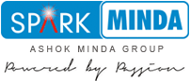

**Media Coverage Report**

|  |
| --- |
| **SPARK MINDA Unveils Its Third Die Casting Plant at PUNE** |

**Dated: February 2018**

|  |  |  |
| --- | --- | --- |
| **News Coverages –**  **MCL Die Casting, New Plant Inauguration, Pune** | | |
| **S.No** | **Date** | **Publication** |
| **PRINT** | | |
| 1 | 10– 02-2018 | Sanjeevani Today |
| 2 | 10– 02-2018 | Prabhat |
| 3 | 10– 02-2018 | Metro Herald |
| 4 | 10– 02-2018 | Gujarat Pranaam |
| 5 | 10– 02-2018 | Divya Gujarat |
| 6 | 10– 02-2018 | Aaj Ka Anand |
| 7 | 10– 02-2018 | Standard Herald |
| 8 | 10– 02-2018 | Herald Youngleader |
| 9 | 10– 02-2018 | Rahat Times |
| 10 | 10– 02-2018 | Aaj |
| **WIRES** | | |
| 1 | 07-02-2018 | UNI |
| **ONLINE** | | |
| 1 | 12-02-2018 | Auto Tech Review |
| 2 | 12-02-2018 | Auto Breaking News |
| 3 | 07-02-2018 | Times Of India |
| 4 | 07-02-2018 | ET Auto |
| 5 | 07-02-2018 | Autocar Professional |
| 6 | 07-02-2018 | INVC News |
| 7 | 07-02-2018 | Bytes Of India |
| 8 | 07-02-2018 | Star News |
| 9 | 07-02-2018 | Skill India Post |
| 10 | 07-02-2018 | The Machinist |
| 11 | 07-02-2018 | Chennai Patrika |
| 12 | 07-02-2018 | Motown Corporate |
| 13 | 07-02-2018 | For Press Release |
| 14 | 07-02-2018 | BIZ shorts |
| 15 | 07-02-2018 | Newzo Pedia |
| 16 | 07-02-2018 | AL Circle |
| 17 | 07-02-2018 | WEB India 123 |
| 18 | 07-02-2018 | This Week India |
| 19 | 07-02-2018 | Mumbai News Network |
| 20 | 07-02-2018 | Manufacturing Industry |
| 21 | 07-02-2018 | NRI News 24 * 7 |
| 22 | 07-02-2018 | Noshwind |

|  |  |
| --- | --- |
| **Publication: Sanjeevani Today** | **Page No: 07** |
| **Edition: Jaipur** | **Date: 10-02-2018** |

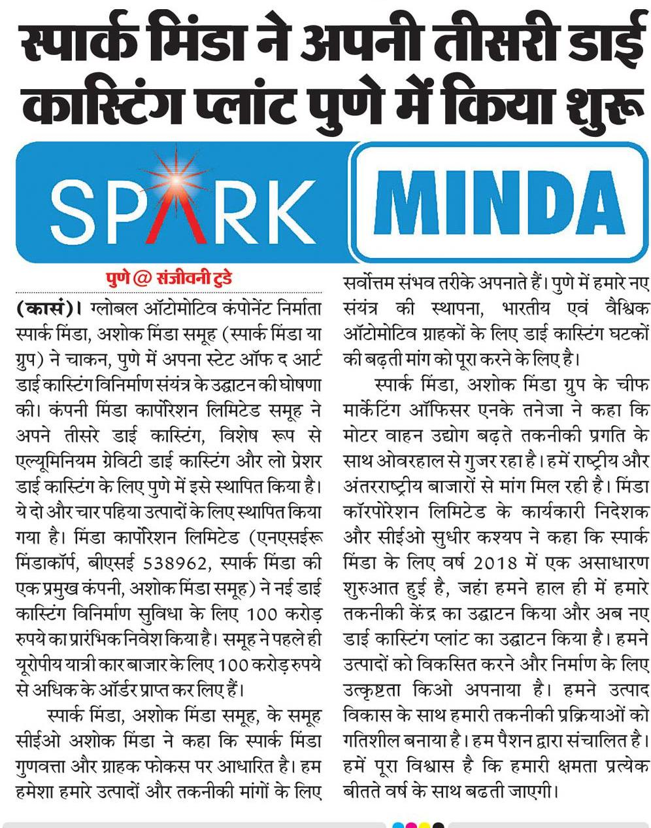

|  |  |
| --- | --- |
| **Publication: Prabhat** | **Page No: 03** |
| **Edition: Ahmedabad** | **Date: 10-02-2018** |

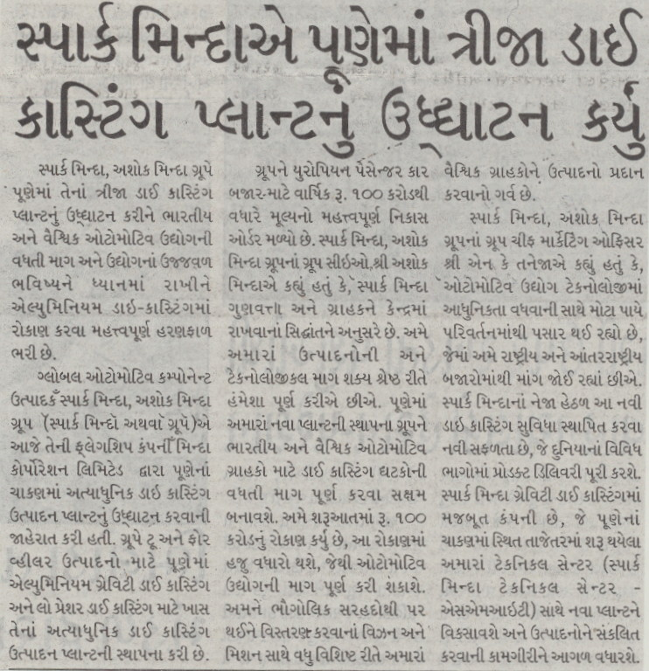

|  |  |
| --- | --- |
| **Publication: Metro Herald** | **Page No: 05** |
| **Edition: Ahmedabad** | **Date: 10-02-2018** |

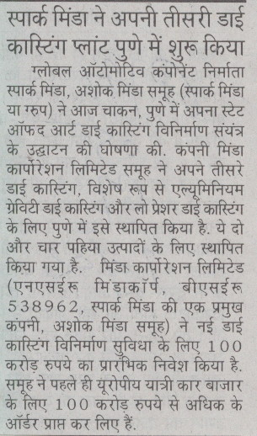

|  |  |
| --- | --- |
| **Publication: Gujarat Pranaam** | **Page No: 03** |
| **Edition: Ahmedabad** | **Date: 10-02-2018** |

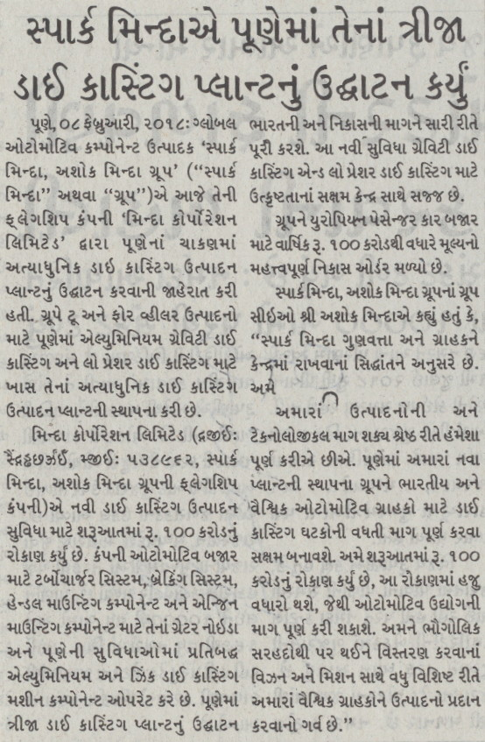

|  |  |
| --- | --- |
| **Publication: Divya Gujarat** | **Page No: 03** |
| **Edition: Ahmedabad** | **Date: 10-02-2018** |

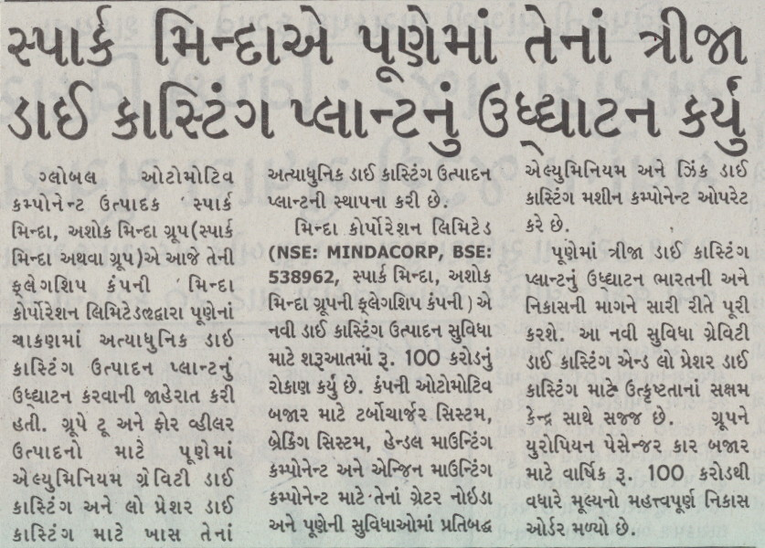

|  |  |
| --- | --- |
| **Publication: Aaj Ka Anand** | **Page No: 08** |
| **Edition: Pune** | **Date: 10-02-2018** |

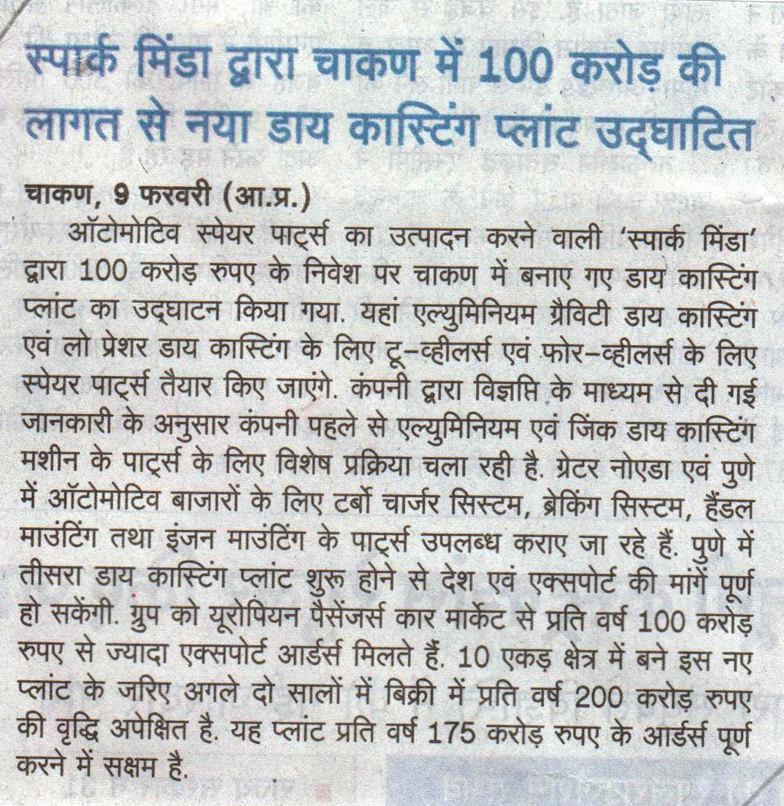

|  |  |
| --- | --- |
| **Publication: Standrad Herald** | **Page No: 11** |
| **Edition: Ahmedabad** | **Date: 12-02-2018** |

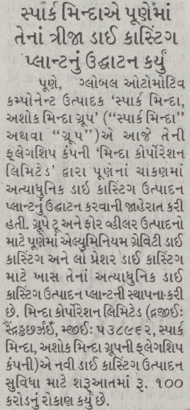

|  |  |
| --- | --- |
| **Publication: Herald Youngleader** | **Page No: 11** |
| **Edition: Ahmedabad** | **Date: 11-02-2018** |

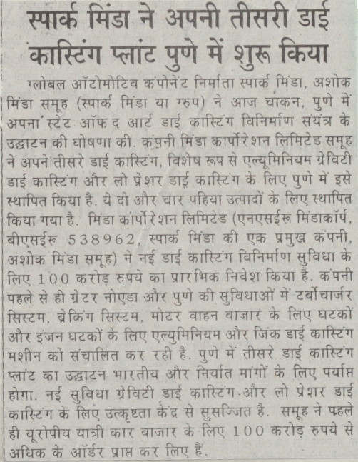

|  |  |
| --- | --- |
| **Publication: Rahat Times** | **Page No: 11** |
| **Edition: Lucknow** | **Date: 11-02-2018** |

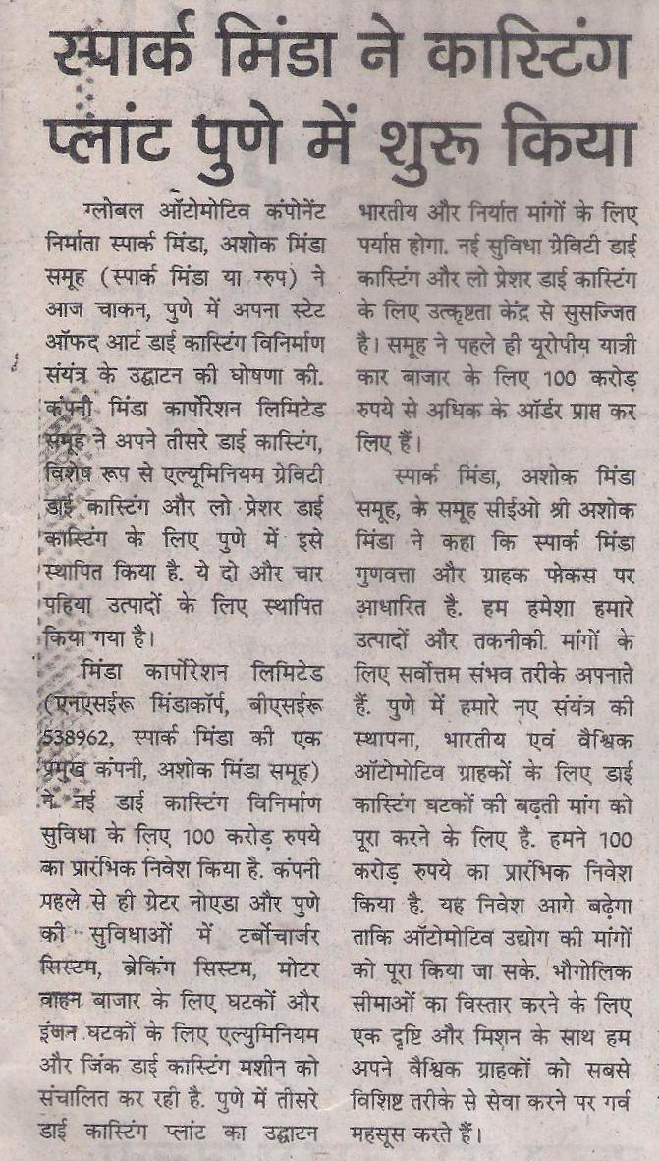

|  |  |
| --- | --- |
| **Publication: Aaj** | **Page No: 09** |
| **Edition: Lucknow** | **Date: 12-02-2018** |

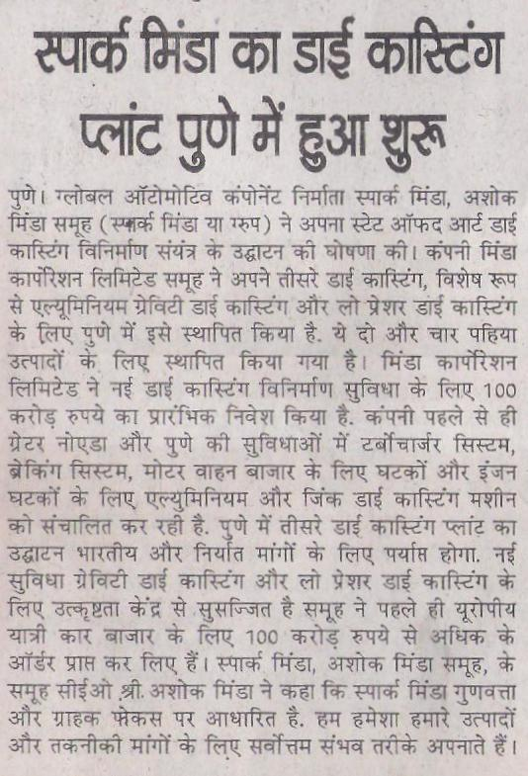

|  |  |
| --- | --- |
| **Publication: UNI** | **Page No:** |
| **Edition: National** | **Date: 07-02-2018** |



**Ashok Minda Group inaugurates Rs 100 cr die casting plant for 2 & 4 wheeler products**

New Delhi, Feb 7 (UNI) Pumping an initial investment of Rs 100 cr, Global Automotive Component Manufacturer 'Spark Minda, Ashok Minda Group' on Wednesday announced the inauguration of its state of the art Die Casting manufacturing plant at Chakan, Pune.  
The Group has set up its third state of art Die Casting manufacturing facility exclusively for Aluminum Gravity Die Casting & Low Pressure Die Casting with machining in Pune for two and four wheeler products.   
The Group has already received significant export order worth more than Rs 100 Cr annual business for European Passenger Car Market.  
Minda Corporation Limited, a flagship company of Spark Minda, Ashok Minda Group, made an initial investment of Rs 100 cr.  
The Company already operates dedicated Aluminium and Zinc Die Casting machine components at their Greater Noida and Pune facilities for turbocharger system, braking system, handle mounting components and engine mounting components for the automotive market.   
Inauguration of third Die Casting plant in Pune will suffice the Indian as well export demands. The new facility is equipped with Competency Centre for Excellence for Gravity Die Casting & Low Pressure Die Casting.   
Mr. Ashok Minda, Group CEO, Spark Minda, Ashok Minda Group said, "Spark Minda follows a strict principle of Quality and Customer focus. We always cater in the best possible manner for our products and technological demands. Establishment of our new plant at Pune will enable Group to suffice the rising demand of Die Casting components for Indian & Global Automotive Customers.   
  
Mr. N.K Taneja, Group Chief Marketing Officer, Spark Minda, Ashok Minda Group said, "Automotive industry is undergoing a huge overhaul with rising technological advancements where we see combined demands coming from National and International markets.   
  
Minda Corporation Limited Executive Director & CEO Sudhir Kashyap said, "Year 2018 marks an exceptional start for Spark Minda, where we recently saw inauguration of our Technical Centre and now new Die Casting plant which will open new horizons for Group in Link - <http://www.uniindia.com/ashok-minda-group-inaugurates-rs-100-cr-die-casting-plant-for-2--4-wheeler-products/business-economy/news/1130799.html#7iEk9w2dY1CmbemD.99>

|  |  |
| --- | --- |
| **Publication: The Times of India** | **Page No:** |
| **Edition: Online** | **Date: 07-02-2018** |



**Spark Minda opens die casting plant in Pune**

CHENNAI: Automotive component major Spark Minda of Ashok Minda Group has opened a die casting manufacturing plant at Chakan, Pune.

This is the third die casting manufacturing facility by the group exclusively for aluminum gravity die casting & low pressure die casting with machining in Pune for two and four-wheeler products.

The group's flagship company Minda Corporation Limited made an initial investment of Rs 100 crore for the new die casting manufacturing facility. The company already operates dedicated aluminium and zinc die casting machine components at its Greater Noida and Pune facilities for turbocharger system, braking system, handle mounting components and engine mounting components for the automotive market.

Inauguration of the third die casting plant in Pune will suffice the Indian as well export demands. The new facility is equipped with Competency Centre for Excellence for Gravity Die Casting & Low Pressure Die Casting.

The group has already received significant export order worth more than Rs 100 crore of annual business for European Passenger Car Market.

Ashok Minda, group CEO, Spark Minda, Ashok Minda Group, said, "Establishment of our new plant in Pune will enable the group to suffice the rising demand of die casting components for Indian and global automotive customers. We have pumped an initial investment of Rs 100 crore. This investment will further escalate so as to cater the demands of automotive industry. We stand proud to serve our global customers in the most distinct manner with a vision and mission to expand beyond geographical boundaries."

N K Taneja, group chief marketing officer, Spark Minda, Ashok Minda Group, said, "Automotive industry is undergoing a huge overhaul with rising technological advancements where we see combined demands coming from National and International markets. Inception of this new die casting facility under the umbrella of Spark Minda will suffice product deliveries to various parts of world. Spark Minda has been a strong player in gravity die casting, continuing the legacy the new plant will develop and integrate products with our recently inaugurated Technical Centre (Spark Minda Technical Centre - SMIT) located at Chakan, Pune."

Link - <https://timesofindia.indiatimes.com/auto/miscellaneous/spark-minda-opens-die-casting-plant-in-pune/articleshow/62821785.cms>

|  |  |
| --- | --- |
| **Publication: ET Auto** | **Page No:** |
| **Edition: Online** | **Date: 07-02-2018** |



**Spark Minda rolls out third die casting plant at Pune**

***The Group has set up its third state of art Die Casting manufacturing facility exclusively for Aluminum Gravity Die Casting & Low Pressure Die Casting with machining in Pune for two and four wheeler products.***

Spark Minda rolls out third die casting plant at PuneNew Delhi: Global Automotive Component Manufacturer ‘Spark Minda, Ashok Minda Group’ today announced the inauguration of its state of the art Die Casting manufacturing plant at Chakan, Pune by its flagship company Minda Corporation.

The Group has set up its third state of art Die Casting manufacturing facility exclusively for Aluminum Gravity Die Casting & Low Pressure Die Casting with machining in Pune for two and four wheeler products.

Minda Corporation, a flagship company of Spark Minda, Ashok Minda Group, made an initial investment of Rs 100 crore for new Die Casting manufacturing facility.

The company already operates dedicated aluminium and zinc die casting machine components at their Greater Noida and Pune facilities for turbocharger system, braking system, handle mounting components and engine mounting components for the automotive market.

Inauguration of third Die Casting plant in Pune will suffice the Indian as well export demands. The new facility is equipped with Competency Centre for Excellence for Gravity Die Casting & Low Pressure Die Casting.

The Group has already received significant Export order worth more than Rs 100 Cr of annual business for European Passenger Car Market.

Ashok Minda, Group CEO, Spark Minda, Ashok Minda Group, said, “Spark Minda follows a strict principle of Quality and Customer focus. We always cater in the best possible manner for our products and technological demands. Establishment of our new plant at Pune will enable Group to suffice the rising demand of Die Casting components for Indian & Global Automotive Customers."

"We have pumped an initial investment of Rs 100 cr, this investment will further escalate so as to cater the demands of automotive industry. We stand proud to serve our global customers in the most distinct manner with a vision and mission to expand beyond geographical boundaries”.

NK Taneja, Group Chief Marketing Officer, Spark Minda, Ashok Minda Group said, “Automotive industry is undergoing a huge overhaul with rising technological advancements where we see combined demands coming from National and International markets."

"Inception of this new Die Casting facility under the umbrella of Spark Minda is a new milestone which will suffice product deliveries to various parts of world. Spark Minda has been strong player in Gravity Die Casting, continuing the legacy the new plant will develop and integrate products with our recently inaugurated Technical Centre (Spark Minda Technical Centre - SMIT) located at Chakan, Pune.”

Sudhir Kashyap, Executive Director & CEO, Minda Corporation Limited said, “Year 2018 marks an exceptional start for Spark Minda, where we recently saw inauguration of our Technical Centre and now new Die Casting plant which will open new horizons for Group in components manufacturing. We have dynamically aligned our technological processes with product development to establish a trade mark of superiority in the products we develop and manufacture. We operate on simple DNA of “Powered by Passion” and we are confident enough to take our capabilities to another level with each passing year”.

Link - <https://auto.economictimes.indiatimes.com/news/industry/spark-minda-unveils-third-die-casting-plant-at-pune/62822124>

|  |  |
| --- | --- |
| **Publication: Auto Car Professional** | **Page No:** |
| **Edition: Online** | **Date: 09-02-2018** |



Spark Minda opens third die casting plant in Pune

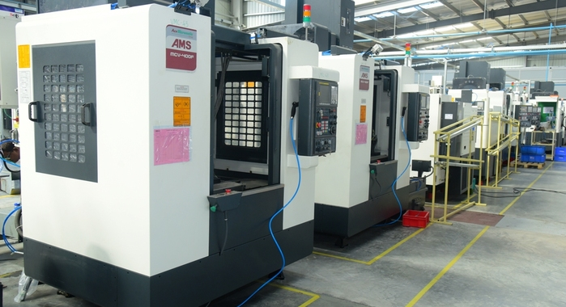

Vertical machining centre at the new plant.

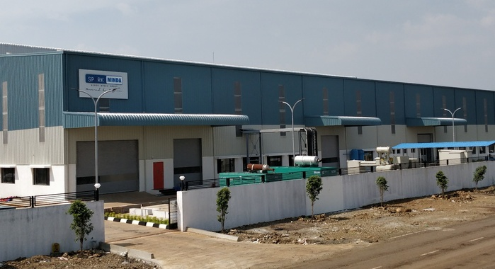

Rs 100 crore investment in new facility will augment aluminium die-casting capacity to cater to demand from both the domestic and export markets

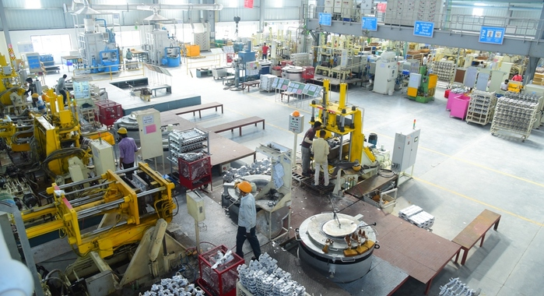

Third die casting facility is exclusively for aluminium gravity die casting and low pressure die casting with machining in Pune for two- and four-wheelers.

[PreviousNext](http://www.autocarpro.in/news-national/spark-minda-die-casting-plant-pune-28021)

**The Spark Minda, Ashok Minda Group has inaugurated its new state-of-the-art die casting manufacturing plant at Chakan, Pune by its flagship company Minda Corporation. The Group’s third die casting facility is exclusively for aluminium gravity die casting and low pressure die casting with machining in Pune for two- and four-wheelers.**

Minda Corporation has made an initial investment of Rs 100 crore in the new unit. The company already produces aluminium and zinc die casting machine components at its Greater Noida and Pune facilities for turbocharger systems, braking systems, handle mounting components and engine mounting components.

The new plant, which is equipped with a Competency Centre for Excellence for Gravity Die Casting and Low Pressure Die Casting, in Pune will cater to both the domestic market and exports. The Group has already received significant export orders worth more than Rs 100 crore of annual business from the European passenger car market.

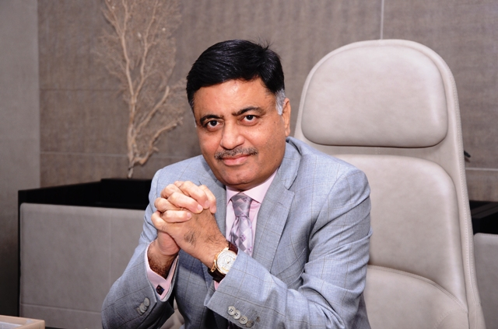

Ashok Minda, Group CEO, Spark Minda, Ashok Minda Group (pictured above) said, “Spark Minda follows a strict principle of quality and customer focus. We always cater in the best possible manner for our products and technological demands. Establishment of our new plant at Pune will enable the Group to cater to the rising demand for die casting components for Indian and global automotive customers.”

N K Taneja, Group chief marketing officer, said, “The automotive industry is undergoing a huge overhaul with rising technological advancements where we see combined demand coming from national and international markets. Spark Minda has been a strong player in gravity die casting. The new plant will develop and integrate products with our[recently inaugurated Technical Centre (Spark Minda Technical Centre - SMIT) located at Chakan, Pune](http://www.autocarpro.in/news-national/spark-minda-inaugurates-technical-centre-pune-27917).”

Link - <http://www.autocarpro.in/news-national/spark-minda-die-casting-plant-pune-28021>

|  |  |
| --- | --- |
| **Publication: International News and Views** | **Page No:** |
| **Edition: Online** | **Date: 09-02-2018** |



# Spark Minda follows a strict principle of Quality and Customer focus

[](http://www.internationalnewsandviews.com/wp-content/uploads/2018/02/Ashok-Minda-Group-CEO-Spa.jpg)

INVC NEWS

New Delhi,

Global Automotive Component Manufacturer ‘SPARK MINDA, Ashok Minda Group’ (“Spark Minda” or “the Group”) today announced the inauguration of its state of the art Die Casting manufacturing plant at Chakan, Pune by its flagship company ‘Minda Corporation Limited’. The Group has set up its third state of art Die Casting manufacturing facility exclusively for Aluminum Gravity Die Casting & Low Pressure Die Casting with machining in Pune for two and four wheeler products.

Minda Corporation Limited (NSE: MINDACORP, BSE: 538962, a flagship company of Spark Minda, Ashok Minda Group) made an initial investment of Rs 100 cr. for new Die Casting manufacturing facility. The Company already operates dedicated Aluminium and Zinc Die Casting machine components at their Greater Noida and Pune facilities for turbocharger system, braking system, handle mounting components and engine mounting components for the automotive market. Inauguration of third Die Casting plant in Pune will suffice the Indian as well export demands. The new facility is equipped with Competency Centre for Excellence for Gravity Die Casting & Low Pressure Die Casting.

The Group has already received significant Export order worth more than Rs 100 Cr of annual business for European Passenger Car Market.

Mr. Ashok Minda, Group CEO, Spark Minda, Ashok Minda Group said, “Spark Minda follows a strict principle of Quality and Customer focus. We always cater in the best possible manner for our products and technological demands. Establishment of our new plant at Pune will enable Group to suffice the rising demand of Die Casting components for Indian & Global Automotive Customers. We have pumped an initial investment of Rs 100 cr, this investment will further escalate so as to cater the demands of automotive industry. We stand proud to serve our global customers in the most distinct manner with a vision and mission to expand beyond geographical boundaries”.

Mr. N.K Taneja, Group Chief Marketing Officer, Spark Minda, Ashok Minda Group said, “Automotive industry is undergoing a huge overhaul with rising technological advancements where we see combined demands coming from National and International markets.  Inception of this new Die Casting facility under the umbrella of Spark Minda is a new milestone which will suffice product deliveries to various parts of world. Spark Minda has been strong player in Gravity Die Casting, continuing the legacy the new plant will develop and integrate products with our recently inaugurated Technical Centre (Spark Minda Technical Centre – SMIT) located at Chakan, Pune.”

Mr Sudhir Kashyap, Executive Director & CEO, Minda Corporation Limited said, “Year 2018 marks an exceptional start for Spark Minda, where we recently saw inauguration of our Technical Centre and now new Die Casting plant which will open new horizons for Group in components manufacturing. We have dynamically aligned our technological processes with product development to establish a trade mark of superiority in the products we develop and manufacture. We operate on simple DNA of “Powered by Passion” and we are confident enough to take our capabilities to another level with each passing year”.

Link - <http://www.internationalnewsandviews.com/spark-minda-follows-a-strict-principle-of-quality-and-customer-focus/>

|  |  |
| --- | --- |
| **Publication: Bytes In India** | **Page No:** |
| **Edition: Online** | **Date: 10-02-2018** |



स्पार्क मिंडाचा डाय कास्टिंग प्लांट

पुणे : जागतिक स्तरावरील ऑटोमोटिव घटकांची उत्पादक असलेल्या, ‘स्पार्क मिंडा, अशोक मिंडा ग्रूप’तर्फे पुण्यातील चाकण येथे डाय कास्टिंगच्या सर्वोत्तम उत्पादक प्लांटचे उद्घाटन आठ फेब्रुवारी २०१८ रोजी करण्यात आले. अॅल्युमिनिअम ग्रॅव्हिटी डाय कास्टिंग आणि लो प्रेशर डाय कास्टिंगसाठी दोन आणि चारचाकी उत्पादनांसाठी पुण्यात ही सुविधा तयार करण्यात आली आहे.

मिंडा कॉर्पोरेशन लिमिटेडतर्फे नव्या डाय कास्टिंग उत्पादन सुविधेसाठी प्राथमिक स्तरावर शंभर कोटी रुपयांची गुंतवणूक करण्यात आली आहे. कंपनी यापूर्वीपासून अॅल्युमिनिअम आणि झिंक डाय कास्टिंग मशिनसाठीचे घटक यासाठी खास प्रक्रिया राबवत आहे. ग्रेटर नोएडा आणि पुणे येथून ऑटोमोटिव बाजारासाठी टर्बोचार्जर सिस्टम, ब्रेकिंग यंत्रणा, हँडल माउंटिंग घटक आणि इंजिन माउंटिंग घटक यासाठी कंपनी सेवा पुरवते. पुण्यातील तिसऱ्या डाय कास्टिंग प्लांटच्या उद्घाटनामुळे भारतातील तसेच निर्यातीच्या मागण्या पुरेशा प्रमाणात पूर्ण करणे शक्य होणार आहे. ही नवी सुविधा, ग्रॅव्हिटी डाय कास्टिंग आणि लो प्रेशर डाय कास्टिंगसाठीच्या सर्वोत्कृष्ट स्पर्धात्मक केंद्रासह सुसज्ज आहे.

स्पार्क मिंडा, अशोक मिंडा ग्रुपचे ग्रुप सीईओ अशोक मिंडा म्हणाले, ‘स्पार्क मिंडा नेहमीच दर्जा आणि ग्राहकांवर लक्ष केंद्रीत करते. आमची उत्पादने आणि तांत्रिक मागण्या यासाठी आम्ही नियमितपणे सर्वोत्तम सेवा देतो. आमच्या पुण्यातील नवीन प्लांटच्या स्थापनेमुळे ग्रुप आता डाय कास्टिंग घटकांच्या भारतातील आणि जागतिक स्तरावरील ऑटोमोटिव ग्राहकांची मागणी पूर्ण करू शकणार आहे.

दृष्टीकोन आणि मिशन यासह भौगोलिक सीमारेषांच्या पलिकडे विस्तार करून, सर्वात चांगल्या प्रकारे आमच्या जागतिक ग्राहकांना सेवा देण्यासाठी आम्ही सज्ज आहोत, त्याचा आम्हाला अभिमान आहे.’

स्पार्क मिंडा, अशोक मिंडा ग्रुपचे ग्रुप चीफ मार्केटिंग अधिकारी एन. के. तानेजा म्हणाले, ‘ऑटोमोटिव उद्योगक्षेत्र सातत्याने अत्याधुनिक तंत्रज्ञानासह वाढते आहे, याबरोबरच राष्ट्रीय आणि आंतरराष्ट्रीय पातळीवर बाजारपेठांतून मागण्याही वाढत आहेत. स्पार्क मिंडा ग्रॅव्हिटी डाय कास्टिंगमधील जोमदार प्लेयर आहे, आणि नव्या प्लांटद्वारे हा वारसा पुढे चालवतानाच नव्या उत्पादनांचा विकास आणि एकीकरणही करण्यात येईल, यासह पुण्यातील चाकण येथे आमच्या नव्या तांत्रिक केंद्राचे (स्पार्क मिंडा टेक्निकल सेंटर - एसएमआयटी) उद्घाटन झाले आहे.’

मिंडा कॉर्पोरेशन लिमिटेडचे कार्यकारी संचालक आणि सीईओ सुधीर कश्यप म्हणाले, ‘आम्ही लक्षणीयरित्या आमच्या तांत्रिक प्रक्रिया, उत्पादन विकासासाठी संलग्नित केल्या आहेत. सर्वोत्तम उत्पादने मिळवण्यासाठी आणि ती विकसित व उत्पादित करण्यासाठी, ही नवी सुविधा देण्यात आली आहे. पॉवर्ड बाय पॅशन या आमच्या मूलमंत्रासह आम्ही सेवा देतो आणि आमच्या क्षमता प्रत्येक वर्षागणिक वाढत्या असतील, याची आम्हाला खात्री आहे.’

स्पार्क मिंडा, अशोक मिंडा ग्रुपची स्थापना १९५८मध्ये झाली. आजच्या घडीला स्पार्क मिंडाच्या जगभरात ३५ उत्पादक सुविधा आहेत. गेल्या काही वर्षांपासून कंपनीने जर्मनी आणि पोलंडमध्ये काही धोरणात्मक संपादने केली आहेत; तसेच इंडोनेशिया, व्हिएतनाम, उझबेकिस्तान आणि झेक रिपब्लिक आदी देशांतील हरित क्षेत्रातील प्रकल्पांमध्येही संपादन केले आहे.

Link – <http://www.bytesofindia.com/Details/?NewsId=5441350292502959881&title=Spark%20Minda%20Die%20Casting%20Plant&SectionId=4907615851820584522&SectionName=%E0%A4%AA%E0%A5%8D%E0%A4%B0%E0%A5%87%E0%A4%B8%20%E0%A4%B0%E0%A4%BF%E0%A4%B2%E0%A5%80%E0%A4%9C>

|  |  |
| --- | --- |
| **Publication: Stars News** | **Page No:** |
| **Edition: Online** | **Date: 08-02-2018** |

### SPARK MINDA Unveils Its Third Die Casting Plant at PUNE

**SPARK MINDA Unveils Its Third Die Casting Plant at PUNE**

Spark Minda, Ashok Minda Group inaugurates its third Die Casting plant at Pune, takes a significant leap towards investment in Aluminium Die-Casting to foresee huge potential & spur demand from growing Indian & Global Automotive Industry.

**Key Highlights of the Plant:**

* Competency Centre for Excellence - Gravity Die Casting & Low Pressure Die Casting with High precision Machining Centre and Powder Coating.
* Well-equipped Test Lab with added facilities like X-Ray, Metallurgy & Mechanical and Environmental test equipment’s**.**
* Spread over 10 acre land, the new plant expects incremental sales of **Rs. 200 cr per annum** in next couple of years, total order booked for this plant of approx. **Rs. 175 cr per annum.**
* existing production capacity for Die Casting Division is 8,500 MT p.a. and for FY 2018-19 target is 9,700 MT p.a.
* **Initial Capital investment of Rs. 100 cr in Phase -1.**

**New Delhi, 07th February 2018**: Global Automotive Component Manufacturer ‘SPARK MINDA, Ashok Minda Group’ (“Spark Minda” or “the Group”) today announced the inauguration of its state of the art Die Casting manufacturing plant at Chakan, Pune by its flagship company ‘Minda Corporation Limited’. The Group has set up its third state of art Die Casting manufacturing facility exclusively for Aluminum Gravity Die Casting & Low Pressure Die Casting with machining in Pune for two and four wheeler products.

Minda Corporation Limited (NSE: MINDACORP, BSE: 538962, a flagship company of Spark Minda, Ashok Minda Group) made an initial investment of Rs 100 cr. for new Die Casting manufacturing facility. The Company already operates dedicated Aluminium and Zinc Die Casting machine components at their Greater Noida and Pune facilities for turbocharger system, braking system, handle mounting components and engine mounting components for the automotive market. Inauguration of third Die Casting plant in Pune will suffice the Indian as well export demands. The new facility is equipped with Competency Centre for Excellence for Gravity Die Casting & Low Pressure Die Casting.

The Group has already received significant Export order worth more than Rs 100 Cr of annual business for European Passenger Car Market.

***Mr. Ashok Minda, Group CEO, Spark Minda, Ashok Minda Group said****, “Spark Minda follows a strict principle of Quality and Customer focus. We always cater in the best possible manner for our products and technological demands. Establishment of our new plant at Pune will enable Group to suffice the rising demand of Die Casting components for Indian & Global Automotive Customers. We have pumped an initial investment of Rs 100 cr, this investment will further escalate so as to cater the demands of automotive industry. We stand proud to serve our global customers in the most distinct manner with a vision and mission to expand beyond geographical boundaries”.*

***Mr. N.K Taneja, Group Chief Marketing Officer, Spark Minda, Ashok Minda Group said,****“Automotive industry is undergoing a huge overhaul with rising technological advancements where we see combined demands coming from National and International markets.  Inception of this new Die Casting facility under the umbrella of Spark Minda is a new milestone which will suffice product deliveries to various parts of world. Spark Minda has been strong player in Gravity Die Casting, continuing the legacy the new plant will develop and integrate products with our recently inaugurated Technical Centre (Spark Minda Technical Centre - SMIT) located at Chakan, Pune.”*

***Mr Sudhir Kashyap, Executive Director & CEO, Minda Corporation Limited said,****“Year 2018 marks an exceptional start for Spark Minda, where we recently saw inauguration of our Technical Centre and now new Die Casting plant which will open new horizons for Group in components manufacturing. We have dynamically aligned our technological processes with product development to establish a trade mark of superiority in the products we develop and manufacture. We operate on simple DNA of “Powered by Passion” and we are confident enough to take our capabilities to another level with each passing year”.*

Spark Minda, Ashok Minda Group’s legacy goes back to 1958 when the first operation was set up in India. Today, 60 years later, Spark Minda has 35 manufacturing facilities world-wide, and provides direct employment to more than  16,000 people and indirect employment to several thousands more. Over the past few years, Spark Minda, Ashok Minda Group has done strategic acquisitions in Germany & Poland along with green-field projects in Indonesia, Vietnam, Uzbekistan and Czech Republic. Our recent endeavours include; setting up a new manufacturing facility at Mexico, besides acquisition of EI LABS India Pvt. Ltd. which will further enhance our Group’s expertise in Connected Mobility and IoT Solutions. The Group has also inaugurated its R&D centre at Pune– Spark Minda Technical Centre (SMIT) which takes a significant leap towards investment in technology leadership and creates a robust platform to emerge as a System Solution provider in the growing automotive industry.

The Group has made several fruitful and successful Joint Ventures/ relationships with the best of the automotive industry players around the world in the domain of designing and manufacturing namely; Stoneridge of USA, VAST of USA, SBHAP of China, SILCA of Italy, Furukawa of Japan & UzAvto of Uzbekistan as our JV Partners. We are privileged to serve Global OEM players such as VW Group, BMW, Daimler, Ford, Renault Nissan, General Motors and so on. In India, our prestigious customer names include the leading OEM’s such as Mahindra, TATA Motors, Ashok Leyland, Honda, Renault Nissan, Maruti Suzuki, Bajaj, Yamaha, TVS etc. We are also catering to Tier-1 Customers such as Honeywell, BorgWarner, Bosch, Brembo, Delphi, Cummins besides others. Our growth oriented initiatives and relationship with some of the most reputed OEM manufacturers have enabled us to report strong growth over the year.

Link - <http://www.spicystarsentertainment.ml/2018/02/spark-minda-unveils-its-third-die.html>

|  |  |
| --- | --- |
| **Publication: Skill India Post** | **Page No:** |
| **Edition: Online** | **Date: 08-02-2018** |



**SPARK MINDA UNVEILS ITS THIRD DIE CASTING PLANT AT PUNE**

Global Automotive Component Manufacturer 'SPARK MINDA, Ashok Minda Group' ("Spark Minda" or "the Group") today announced the inauguration of its state of the art Die Casting manufacturing plant at Chakan, Pune by its flagship company 'Minda Corporation Limited'.

New Delhi, 08th February 2018: Global Automotive Component Manufacturer 'SPARK MINDA, Ashok Minda Group' ("Spark Minda" or "the Group") today announced the inauguration of its state of the art Die Casting manufacturing plant at Chakan, Pune by its flagship company 'Minda Corporation Limited'. The Group has set up its third state of art Die Casting manufacturing facility exclusively for Aluminum Gravity Die Casting & Low Pressure Die Casting with machining in Pune for two and four wheeler products. Key Highlights of the Plant: • Competency Centre for Excellence - Gravity Die Casting & Low Pressure Die Casting with High precision Machining Centre and Powder Coating. • Well-equipped Test Lab with added facilities like X-Ray, Metallurgy & Mechanical and Environmental test equipment's. • Spread over 10 acre land, the new plant expects incremental sales of Rs. 200 cr per annum in next couple of years, total order booked for this plant of approx. Rs. 175 cr per annum. • Existing production capacity for Die Casting Division is 8,500 MT p.a. and for FY 2018-19 target is 9,700 MT p.a. • Initial Capital investment of Rs. 100 cr in Phase -1. Minda Corporation Limited (NSE: MINDACORP, BSE: 538962, a flagship company of Spark Minda, Ashok Minda Group) made an initial investment of Rs 100 cr. for new Die Casting manufacturing facility. The Company already operates dedicated Aluminium and Zinc Die Casting machine components at their Greater Noida and Pune facilities for turbocharger system, braking system, handle mounting components and engine mounting components for the automotive market. Inauguration of third Die Casting plant in Pune will suffice the Indian as well export demands. The new facility is equipped with Competency Centre for Excellence for Gravity Die Casting & Low Pressure Die Casting. The Group has already received significant Export order worth more than Rs 100 Cr of annual business for European Passenger Car Market. Mr. Ashok Minda, Group CEO, Spark Minda, Ashok Minda Group said, "Spark Minda follows a strict principle of Quality and Customer focus. We always cater in the best possible manner for our products and technological demands. Establishment of our new plant at Pune will enable Group to suffice the rising demand of Die Casting components for Indian & Global Automotive Customers. We have pumped an initial investment of Rs 100 cr, this investment will further escalate so as to cater the demands of automotive industry. We stand proud to serve our global customers in the most distinct manner with a vision and mission to expand beyond geographical boundaries". Mr. N.K Taneja, Group Chief Marketing Officer, Spark Minda, Ashok Minda Group said, "Automotive industry is undergoing a huge overhaul with rising technological advancements where we see combined demands coming from National and International markets. Inception of this new Die Casting facility under the umbrella of Spark Minda is a new milestone which will suffice product deliveries to various parts of world. Spark Minda has been strong player in Gravity Die Casting, continuing the legacy the new plant will develop and integrate products with our recently inaugurated Technical Centre (Spark Minda Technical Centre - SMIT) located at Chakan, Pune." Mr Sudhir Kashyap, Executive Director & CEO, Minda Corporation Limited said, "Year 2018 marks an exceptional start for Spark Minda, where we recently saw inauguration of our Technical Centre and now new Die Casting plant which will open new horizons for Group in components manufacturing. We have dynamically aligned our technological processes with product development to establish a trade mark of superiority in the products we develop and manufacture. We operate on simple DNA of "Powered by Passion" and we are confident enough to take our capabilities to another level with each passing year". Spark Minda, Ashok Minda Group's legacy goes back to 1958 when the first operation was set up in India. Today, 60 years later, Spark Minda has 35 manufacturing facilities world-wide, and provides direct employment to more than 16,000 people and indirect employment to several thousands more. Over the past few years, Spark Minda, Ashok Minda Group has done strategic acquisitions in Germany & Poland along with green-field projects in Indonesia, Vietnam, Uzbekistan and Czech Republic. Our recent endeavours include; setting up a new manufacturing facility at Mexico, besides acquisition of EI LABS India Pvt. Ltd. which will further enhance our Group's expertise in Connected Mobility and IoT Solutions. The Group has also inaugurated its R&D centre at Pune– Spark Minda Technical Centre (SMIT) which takes a significant leap towards investment in technology leadership and creates a robust platform to emerge as a System Solution provider in the growing automotive industry. The Group has made several fruitful and successful Joint Ventures/ relationships with the best of the automotive industry players around the world in the domain of designing and manufacturing namely; Stoneridge of USA, VAST of USA, SBHAP of China, SILCA of Italy, Furukawa of Japan & UzAvto of Uzbekistan as our JV Partners. We are privileged to serve Global OEM players such as VW Group, BMW, Daimler, Ford, Renault Nissan, General Motors and so on. In India, our prestigious customer names include the leading OEM's such as Mahindra, TATA Motors, Ashok Leyland, Honda, Renault Nissan, Maruti Suzuki, Bajaj, Yamaha, TVS etc. We are also catering to Tier-1 Customers such as Honeywell, BorgWarner, Bosch, Brembo, Delphi, Cummins besides others. Our growth oriented initiatives and relationship with some of the most reputed OEM manufacturers have enabled us to report strong growth over the year.

[**http://www.skillindiapost.com/category/other/automotive/spark-minda-unveils-its-third-die-casting-plant-at-pune-558821**](http://www.skillindiapost.com/category/other/automotive/spark-minda-unveils-its-third-die-casting-plant-at-pune-558821)

|  |  |
| --- | --- |
| **Publication: The Machinist** | **Page No:** |
| **Edition: Online** | **Date: 08-02-2018** |



**Spark Minda unveils its third die casting plant at Pune**

Well-equipped Test Lab with added facilities like X-Ray, Metallurgy & Mechanical and Environmental test equipment

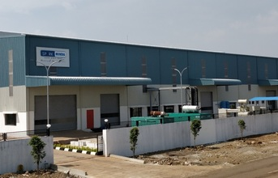

Global Automotive Component Manufacturer ‘SPARK MINDA, Ashok Minda Group’ (“Spark Minda” or “the Group”) announced the inauguration of its state of the art Die Casting manufacturing plant at Chakan, Pune by its flagship company ‘Minda Corporation Ltd’. The Group has set up its third state of art Die Casting manufacturing facility exclusively for Aluminum Gravity Die Casting & Low Pressure Die Casting with machining in Pune for two and four wheeler products.

Minda Corporation made an initial investment of Rs 100 cr. for new Die Casting manufacturing facility. The Company already operates dedicated Aluminium and Zinc Die Casting machine components at their Greater Noida and Pune facilities for turbocharger system, braking system, handle mounting components and engine mounting components for the automotive market. Inauguration of third Die Casting plant in Pune will suffice the Indian as well export demands. The new facility is equipped with Competency Centre for Excellence for Gravity Die Casting & Low Pressure Die Casting.

Link - <http://www.themachinist.in/worldwidemedia/news/4084/spark-minda-unveils-die-casting-plant-pune>

|  |  |
| --- | --- |
| **Publication: Chennai Patrika** | **Page No:** |
| **Edition: Online** | **Date: 08-02-2018** |

#### 

#### [SPARK MINDA Unveils Its Third Die Casting Plant at PUNE](http://news.chennaipatrika.com/)

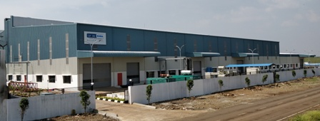

*Spark Minda, Ashok Minda Group inaugurates its third Die Casting plant at Pune, takes a significant leap towards investment in Aluminium Die-Casting to foresee huge potential & spur demand from growing Indian & Global Automotive Industry.*

**Key Highlights of the Plant:**

*\* Competency Centre for Excellence - Gravity Die Casting & Low Pressure Die Casting with High precision Machining Centre and Powder Coating.*

*\* Well-equipped Test Lab with added facilities like X-Ray, Metallurgy & Mechanical and Environmental test equipment’s***.**

*\* Spread over 10 acre land, the new plant expects incremental sales of Rs. 200 cr per annum in next couple of years, total order booked for this plant of approx. Rs. 175 cr per annum.*

*\* Existing production capacity for Die Casting Division is 8,500 MT p.a. and for FY 2018-19 target is 9,700 MT p.a.*

*\* Initial Capital investment of Rs. 100 cr in Phase -1.*

**New Delhi, 07th February 2018**: Global Automotive Component Manufacturer ‘SPARK MINDA, Ashok Minda Group’ (“Spark Minda” or “the Group”) today announced the inauguration of its state of the art Die Casting manufacturing plant at Chakan, Pune by its flagship company ‘Minda Corporation Limited’. The Group has set up its third state of art Die Casting manufacturing facility exclusively for Aluminum Gravity Die Casting & Low Pressure Die Casting with machining in Pune for two and four wheeler products.

Minda Corporation Limited (NSE: MINDACORP, BSE: 538962, a flagship company of Spark Minda, Ashok Minda Group) made an initial investment of Rs 100 cr. for new Die Casting manufacturing facility. The Company already operates dedicated Aluminium and Zinc Die Casting machine components at their Greater Noida and Pune facilities for turbocharger system, braking system, handle mounting components and engine mounting components for the automotive market. Inauguration of third Die Casting plant in Pune will suffice the Indian as well export demands. The new facility is equipped with Competency Centre for Excellence for Gravity Die Casting & Low Pressure Die Casting.

The Group has already received significant Export order worth more than Rs 100 Cr of annual business for European Passenger Car Market.

*Mr. Ashok Minda, Group CEO, Spark Minda, Ashok Minda Group said, “Spark Minda follows a strict principle of Quality and Customer focus. We always cater in the best possible manner for our products and technological demands. Establishment of our new plant at Pune will enable Group to suffice the rising demand of Die Casting components for Indian & Global Automotive Customers. We have pumped an initial investment of Rs 100 cr, this investment will further escalate so as to cater the demands of automotive industry. We stand proud to serve our global customers in the most distinct manner with a vision and mission to expand beyond geographical boundaries”.*

*Mr. N.K Taneja, Group Chief Marketing Officer, Spark Minda, Ashok Minda Group said, “Automotive industry is undergoing a huge overhaul with rising technological advancements where we see combined demands coming from National and International markets.  Inception of this new Die Casting facility under the umbrella of Spark Minda is a new milestone which will suffice product deliveries to various parts of world. Spark Minda has been strong player in Gravity Die Casting, continuing the legacy the new plant will develop and integrate products with our recently inaugurated Technical Centre (Spark Minda Technical Centre - SMIT) located at Chakan, Pune.”*

*Mr Sudhir Kashyap, Executive Director & CEO, Minda Corporation Limited said, “Year 2018 marks an exceptional start for Spark Minda, where we recently saw inauguration of our Technical Centre and now new Die Casting plant which will open new horizons for Group in components manufacturing. We have dynamically aligned our technological processes with product development to establish a trade mark of superiority in the products we develop and manufacture. We operate on simple DNA of “Powered by Passion” and we are confident enough to take our capabilities to another level with each passing year”.*

Spark Minda, Ashok Minda Group’s legacy goes back to 1958 when the first operation was set up in India. Today, 60 years later, Spark Minda has 35 manufacturing facilities world-wide, and provides direct employment to more than  16,000 people and indirect employment to several thousands more. Over the past few years, Spark Minda, Ashok Minda Group has done strategic acquisitions in Germany & Poland along with green-field projects in Indonesia, Vietnam, Uzbekistan and Czech Republic. Our recent endeavours include; setting up a new manufacturing facility at Mexico, besides acquisition of EI LABS India Pvt. Ltd. which will further enhance our Group’s expertise in Connected Mobility and IoT Solutions. The Group has also inaugurated its R&D centre at Pune– Spark Minda Technical Centre (SMIT) which takes a significant leap towards investment in technology leadership and creates a robust platform to emerge as a System Solution provider in the growing automotive industry.

The Group has made several fruitful and successful Joint Ventures/ relationships with the best of the automotive industry players around the world in the domain of designing and manufacturing namely; Stoneridge of USA, VAST of USA, SBHAP of China, SILCA of Italy, Furukawa of Japan & UzAvto of Uzbekistan as our JV Partners. We are privileged to serve Global OEM players such as VW Group, BMW, Daimler, Ford, Renault Nissan, General Motors and so on. In India, our prestigious customer names include the leading OEM’s such as Mahindra, TATA Motors, Ashok Leyland, Honda, Renault Nissan, Maruti Suzuki, Bajaj, Yamaha, TVS etc. We are also catering to Tier-1 Customers such as Honeywell, BorgWarner, Bosch, Brembo, Delphi, Cummins besides others. Our growth oriented initiatives and relationship with some of the most reputed OEM manufacturers have enabled us to report strong growth over the year.

Link - <http://news.chennaipatrika.com/post/2018/02/07/SPARK-MINDA-Unveils-Its-Third-Die-Casting-Plant-at-PUNE.aspx>

|  |  |
| --- | --- |
| **Publication: Motown Corporate** | **Page No:** |
| **Edition: Online** | **Date: 08-02-2018** |



[**Previous**](http://www.micorporate.com/Bureau/Auto-Components/378/Sunjay-Kapur-controlled-Sona-Group-unveils-new-logo-Motown-India-Bureau) [**View All**](http://www.micorporate.com/Bureau/Auto-Components/View)

# SPARK MINDA UNVEILS ITS THIRD DIE CASTING PLANT IN PUNE

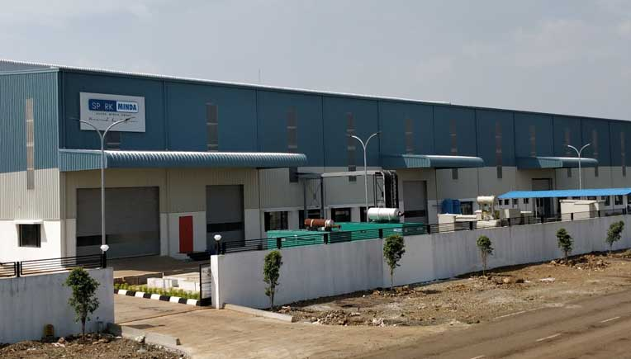

Global automotive component manufacturer Spark Minda, Ashok Minda Group announced the inauguration of its state of the art die casting manufacturing plant at Chakan, Pune by its flagship company Minda Corporation Limited. The Group has set up its third state of art die casting manufacturing facility exclusively for aluminum gravity die casting & low pressure die casting with machining in Pune for two and four wheeler products.

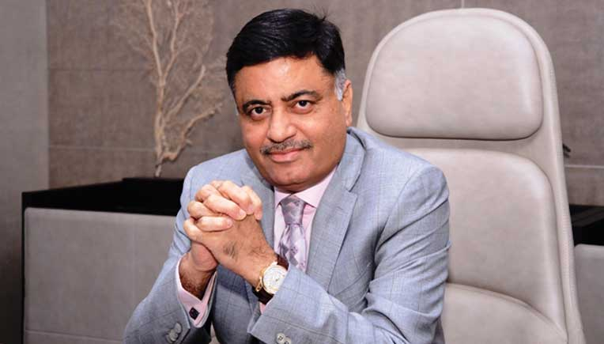

Minda Corporation Limited, a flagship company of Spark Minda, Ashok Minda Group made an initial investment of Rs 100 cr. for new die casting manufacturing facility. The company already operates dedicated aluminium and zinc die casting machine components at their Greater Noida and Pune facilities for turbocharger system, braking system, handle mounting components and engine mounting components for the automotive market. Inauguration of third Die Casting plant in Pune will suffice the Indian as well export demands. The new facility is equipped with Competency Centre for Excellence for gravity die casting & low pressure die casting.

 The Group has already received significant export order worth more than Rs 100 cr of annual business for European passenger car market.

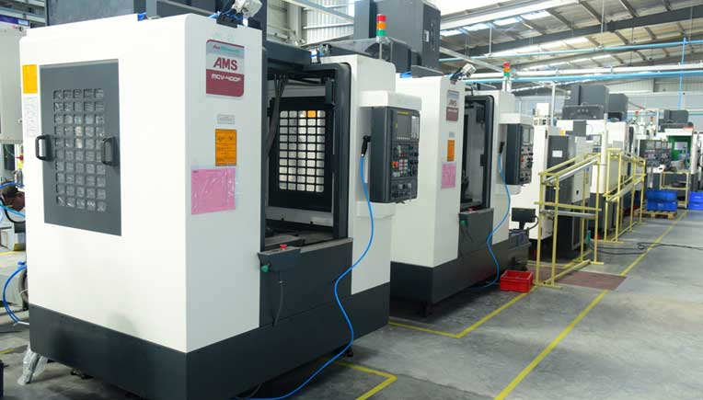

 Ashok Minda, Group CEO, Spark Minda, Ashok Minda Group said, “Spark Minda follows a strict principle of Quality and Customer focus. We always cater in the best possible manner for our products and technological demands. Establishment of our new plant at Pune will enable Group to suffice the rising demand of die casting components for indian & global automotive customers. We have pumped an initial investment of Rs 100 cr, this investment will further escalate so as to cater the demands of automotive industry. We stand proud to serve our global customers in the most distinct manner with a vision and mission to expand beyond geographical boundaries”.

N.K Taneja, Group Chief Marketing Officer, Spark Minda, Ashok Minda Group said, “Automotive industry is undergoing a huge overhaul with rising technological advancements where we see combined demands coming from National and International markets.  Inception of this new Die Casting facility under the umbrella of Spark Minda is a new milestone which will suffice product deliveries to various parts of world. Spark Minda has been strong player in Gravity Die Casting, continuing the legacy the new plant will develop and integrate products with our recently inaugurated Technical Centre (Spark Minda Technical Centre - SMIT) located at Chakan, Pune.”

 Sudhir Kashyap, Executive Director & CEO, Minda Corporation Limited said, “Year 2018 marks an exceptional start for Spark Minda, where we recently saw inauguration of our Technical Centre and now new Die Casting plant which will open new horizons for Group in components manufacturing. We have dynamically aligned our technological processes with product development to establish a trade mark of superiority in the products we develop and manufacture. We operate on simple DNA of “Powered by Passion” and we are confident enough to take our capabilities to another level with each passing year”.

Link - <http://www.micorporate.com/Bureau/Auto-Components/379/Spark-Minda-unveils-its-third-die-casting-plant-in-Pune-Motown-India-Bureau>

|  |  |
| --- | --- |
| **Publication: For Press Release** | **Page No:** |
| **Edition: Online** | **Date: 08-02-2018** |

**SPARK MINDA Unveils Its Third Die Casting Plant at PUNE**

Spark Minda, Ashok Minda Group inaugurates its third Die Casting plant at Pune, takes a significant leap towards investment in Aluminium Die-Casting to foresee huge potential & spur demand from growing Indian & Global Automotive Industry.

Key Highlights of the Plant:

Competency Centre for Excellence - Gravity Die Casting & Low Pressure Die Casting with High precision Machining Centre and Powder Coating.

Well-equipped Test Lab with added facilities like X-Ray, Metallurgy & Mechanical and Environmental test equipment’s.

Spread over 10 acre land, the new plant expects incremental sales of Rs. 200 cr per annum in next couple of years, total order booked for this plant of approx. Rs. 175 cr per annum.

existing production capacity for Die Casting Division is 8,500 MT p.a. and for FY 2018-19 target is 9,700 MT p.a.

Initial Capital investment of Rs. 100 cr in Phase -1.

New Delhi, 07th February 2018: Global Automotive Component Manufacturer ‘SPARK MINDA, Ashok Minda Group’ (“Spark Minda” or “the Group”) today announced the inauguration of its state of the art Die Casting manufacturing plant at Chakan, Pune by its flagship company ‘Minda Corporation Limited’. The Group has set up its third state of art Die Casting manufacturing facility exclusively for Aluminum Gravity Die Casting & Low Pressure Die Casting with machining in Pune for two and four wheeler products.

Minda Corporation Limited (NSE: MINDACORP, BSE: 538962, a flagship company of Spark Minda, Ashok Minda Group) made an initial investment of Rs 100 cr. for new Die Casting manufacturing facility. The Company already operates dedicated Aluminium and Zinc Die Casting machine components at their Greater Noida and Pune facilities for turbocharger system, braking system, handle mounting components and engine mounting components for the automotive market. Inauguration of third Die Casting plant in Pune will suffice the Indian as well export demands. The new facility is equipped with Competency Centre for Excellence for Gravity Die Casting & Low Pressure Die Casting.

The Group has already received significant Export order worth more than Rs 100 Cr of annual business for European Passenger Car Market.

Mr. Ashok Minda, Group CEO, Spark Minda, Ashok Minda Group said, “Spark Minda follows a strict principle of Quality and Customer focus. We always cater in the best possible manner for our products and technological demands. Establishment of our new plant at Pune will enable Group to suffice the rising demand of Die Casting components for Indian & Global Automotive Customers. We have pumped an initial investment of Rs 100 cr, this investment will further escalate so as to cater the demands of automotive industry. We stand proud to serve our global customers in the most distinct manner with a vision and mission to expand beyond geographical boundaries”.

Mr. N.K Taneja, Group Chief Marketing Officer, Spark Minda, Ashok Minda Group said, “Automotive industry is undergoing a huge overhaul with rising technological advancements where we see combined demands coming from National and International markets. Inception of this new Die Casting facility under the umbrella of Spark Minda is a new milestone which will suffice product deliveries to various parts of world. Spark Minda has been strong player in Gravity Die Casting, continuing the legacy the new plant will develop and integrate products with our recently inaugurated Technical Centre (Spark Minda Technical Centre - SMIT) located at Chakan, Pune.”

Mr Sudhir Kashyap, Executive Director & CEO, Minda Corporation Limited said, “Year 2018 marks an exceptional start for Spark Minda, where we recently saw inauguration of our Technical Centre and now new Die Casting plant which will open new horizons for Group in components manufacturing. We have dynamically aligned our technological processes with product development to establish a trade mark of superiority in the products we develop and manufacture. We operate on simple DNA of “Powered by Passion” and we are confident enough to take our capabilities to another level with each passing year”.

Link - <https://www.forpressrelease.com/forpressrelease-396450-spark-minda-unveils-its-third-die-casting-plant-at-pune.html>

|  |  |
| --- | --- |
| **Publication: BIZ Shorts** | **Page No:** |
| **Edition: Online** | **Date: 08-02-2018** |

**Spark Minda inaugurates 3rd die casting plant in Pune**

Spark Minda has inaugurated its third die casting manufacturing plant at Chakan, Pune by its flagship company ‘Minda Corporation Ltd’, at an investment of Rs 100 crore.

The plant has been set up exclusively for Aluminum Gravity Die Casting & Low Pressure Die Casting with machining for two and four wheeler products.

Ashok Minda, Group CEO, Spark Minda, Ashok Minda Group, said, “Spark Minda follows a strict principle of Quality and Customer focus. We always cater in the best possible manner for our products and technological demands. Establishment of our new plant at Pune will enable Group to suffice the rising demand of Die Casting components for Indian & Global Automotive Customers.”

He added: “We have pumped an initial investment of Rs 100 crore, this investment will further escalate so as to cater the demands of automotive industry. We stand proud to serve our global customers in the most distinct manner with a vision and mission to expand beyond geographical boundaries.”

Link - <http://bizshorts.in/spark-minda-inaugurates-3rd-die-casting-plant-in-pune/>

|  |  |
| --- | --- |
| **Publication: Steel Guru** | **Page No:** |
| **Edition: Online** | **Date: 08-02-2018** |

# Spark Minda rolls out 3rd die casting plant at Pune

## Auto News - Published on Fri, 09 Feb 2018

[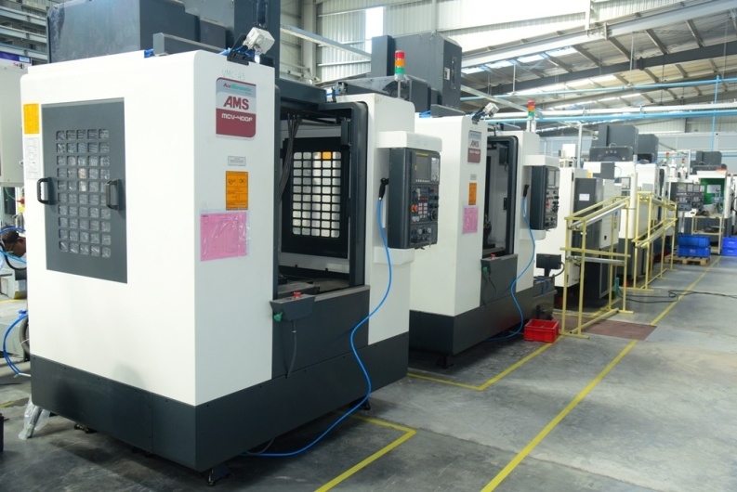](https://steelguru.com/auto/spark-minda-rolls-out-3rd-die-casting-plant-at-pune/501944#spark-minda-rolls-out-3rd-die-casting-plant_84912.jpg)

Image Source: etb2bimg.comGlobal Automotive Component Manufacturer ‘Spark Minda, Ashok Minda Group’ announced the inauguration of its state of the art Die Casting manufacturing plant at Chakan, Pune by its flagship company Minda Corporation. The Group has set up its third state of art Die Casting manufacturing facility exclusively for Aluminum Gravity Die Casting & Low Pressure Die Casting with machining in Pune for two and four wheeler products.  
  
Minda Corporation, a flagship company of Spark Minda, Ashok Minda Group, made an initial investment of Rs 100 crore for new Die Casting manufacturing facility.  
  
The company already operates dedicated aluminium and zinc die casting machine components at their Greater Noida and Pune facilities for turbocharger system, braking system, handle mounting components and engine mounting components for the automotive market.  
  
Inauguration of third Die Casting plant in Pune will suffice the Indian as well export demands. The new facility is equipped with Competency Centre for Excellence for Gravity Die Casting & Low Pressure Die Casting.  
  
The Group has already received significant Export order worth more than Rs 100 Cr of annual business for European Passenger Car Market.  
  
Ashok Minda, Group CEO, Spark Minda, Ashok Minda Group, said, “Spark Minda follows a strict principle of Quality and Customer focus. We always cater in the best possible manner for our products and technological demands. Establishment of our new plant at Pune will enable Group to suffice the rising demand of Die Casting components for Indian & Global Automotive Customers."  
  
He said that "We have pumped an initial investment of Rs 100 cr, this investment will further escalate so as to cater the demands of automotive industry. We stand proud to serve our global customers in the most distinct manner with a vision and mission to expand beyond geographical boundaries.”  
  
NK Taneja, Group Chief Marketing Officer, Spark Minda, Ashok Minda Group said, “Automotive industry is undergoing a huge overhaul with rising technological advancements where we see combined demands coming from National and International markets."  
  
"Inception of this new Die Casting facility under the umbrella of Spark Minda is a new milestone which will suffice product deliveries to various parts of world. Spark Minda has been strong player in Gravity Die Casting, continuing the legacy the new plant will develop and integrate products with our recently inaugurated Technical Centre (Spark Minda Technical Centre - SMIT) located at Chakan, Pune.”  
  
Mr Sudhir Kashyap, Executive Director & CEO, Minda Corporation Limited said, “Year 2018 marks an exceptional start for Spark Minda, where we recently saw inauguration of our Technical Centre and now new Die Casting plant which will open new horizons for Group in components manufacturing. We have dynamically aligned our technological processes with product development to establish a trade mark of superiority in the products we develop and manufacture. We operate on simple DNA of “Powered by Passion” and we are confident enough to take our capabilities to another level with each passing year.”

Link - <https://steelguru.com/auto/spark-minda-rolls-out-3rd-die-casting-plant-at-pune/501944>

|  |  |
| --- | --- |
| **Publication: Newzo Pedia** | **Page No:** |
| **Edition: Online** | **Date: 08-02-2018** |



# SPARK MINDA Unveils Its Third Die Casting Plant at PUNE

[4 DAYS AGO](http://www.newzopedia.com/2018/02/spark-minda-unveils-its-third-die.html)

2 MINUTE

READ

Spark Minda, Ashok Minda Group inaugurates its third Die Casting plant at Pune, takes a significant leap towards investment in Aluminium Die-Casting to foresee huge potential & spur demand from growing Indian & Global Automotive Industry.

[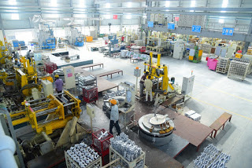](https://4.bp.blogspot.com/-GcV1hho8_xQ/WnwFfcVqD9I/AAAAAAAAAPY/iOAm4MXvc_gWN3mJhr4PapNbT83hOo7zgCEwYBhgL/s1600/Gravity+Die+Casting+Process.JPG)

**Key Highlights of the Plant:**

* Competency Centre for Excellence - Gravity Die Casting & Low Pressure Die Casting with High precision Machining Centre and Powder Coating.
* Well-equipped Test Lab with added facilities like X-Ray, Metallurgy & Mechanical and Environmental test equipment’s**.**
* Spread over 10 acre land, the new plant expects incremental sales of **Rs. 200 cr per annum** in next couple of years, total order booked for this plant of approx. **Rs. 175 cr per annum.**
* existing production capacity for Die Casting Division is 8,500 MT p.a. and for FY 2018-19 target is 9,700 MT p.a.
* **Initial Capital investment of Rs. 100 cr in Phase -1.**

**New Delhi, 07th February 2018**: Global Automotive Component Manufacturer ‘SPARK MINDA, Ashok Minda Group’ (“Spark Minda” or “the Group”) today announced the inauguration of its state of the art Die Casting manufacturing plant at Chakan, Pune by its flagship company ‘Minda Corporation Limited’. The Group has set up its third state of art Die Casting manufacturing facility exclusively for Aluminum Gravity Die Casting & Low Pressure Die Casting with machining in Punefor two and four wheeler products.

Minda Corporation Limited (NSE: MINDACORP, BSE: 538962, a flagship company of Spark Minda, Ashok Minda Group) made an initial investment of Rs 100 cr. for new Die Casting manufacturing facility. The Company already operates dedicated Aluminium and Zinc Die Casting machine components at their Greater Noida and Pune facilities for turbocharger system, braking system, handle mounting components and engine mounting components for the automotive market. Inauguration of third Die Casting plant in Pune will suffice the Indian as well export demands. The new facility is equipped with Competency Centre for Excellence for Gravity Die Casting & Low Pressure Die Casting.

The Group has already received significant Export order worth more than Rs 100 Cr of annual business for European Passenger Car Market.

[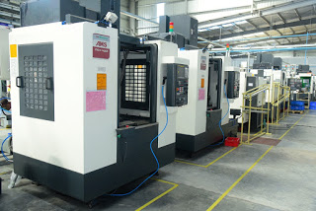](https://1.bp.blogspot.com/-sjvLq5dhq0o/WnwFezACUQI/AAAAAAAAAPU/3v8A68QBbwUI1eecxiftvdnGrpEQzBpzQCEwYBhgL/s1600/Vertical+Machining+Centre.JPG)

**Mr. Ashok Minda, Group CEO, Spark Minda, Ashok Minda Group said**, “Spark Minda follows a strict principle of Quality and Customer focus. We always cater in the best possible manner for our products and technological demands. Establishment of our new plant at Pune will enable Group to suffice the rising demand of Die Casting components for Indian & Global Automotive Customers. We have pumped an initial investment of Rs 100 cr, this investment will further escalate so as to cater the demands of automotive industry. We stand proud to serve our global customers in the most distinct manner with a vision and mission to expand beyond geographical boundaries”.

**Mr. N.K Taneja, Group Chief Marketing Officer, Spark Minda, Ashok Minda Group said,** “Automotive industry is undergoing a huge overhaul with rising technological advancements where we see combined demands coming from National and International markets.  Inception of this new Die Casting facility under the umbrella of Spark Minda is a new milestone which will suffice product deliveries to various parts of world. Spark Minda has been strong player in Gravity Die Casting, continuing the legacy the new plant will develop and integrate products with our recently inaugurated Technical Centre (Spark Minda Technical Centre - SMIT) located at Chakan, Pune.”

**Mr Sudhir Kashyap, Executive Director & CEO, Minda Corporation Limited said,**“Year 2018 marks an exceptional start for Spark Minda, where we recently saw inauguration of our Technical Centre and now new Die Casting plant which will open new horizons for Group in components manufacturing. We have dynamically aligned our technological processes with product development to establish a trade mark of superiority in the products we develop and manufacture. We operate on simple DNA of “Powered by Passion” and we are confident enough to take our capabilities to another level with each passing year”.

Link - <http://www.newzopedia.com/2018/02/spark-minda-unveils-its-third-die.html>

|  |  |
| --- | --- |
| **Publication: Al Circle** | **Page No:** |
| **Edition: Online** | **Date: 08-02-2018** |

Spark Minda inaugurates aluminium die casting factory in Pune

Spark Minda, Ashok Minda Group has opened third die casting facility with an initial capital investment of INR 100 crore in Phase -1. The Group has established manufacturing facility exclusively for aluminium gravity die casting & low pressure die casting with machining in Pune for two and four wheeler products.

Ashok Minda, Group CEO, Spark Minda, Ashok Minda Group said, “Establishment of our new plant at Pune will enable Group to suffice the rising demand of Die Casting components for Indian & Global Automotive Customers.”

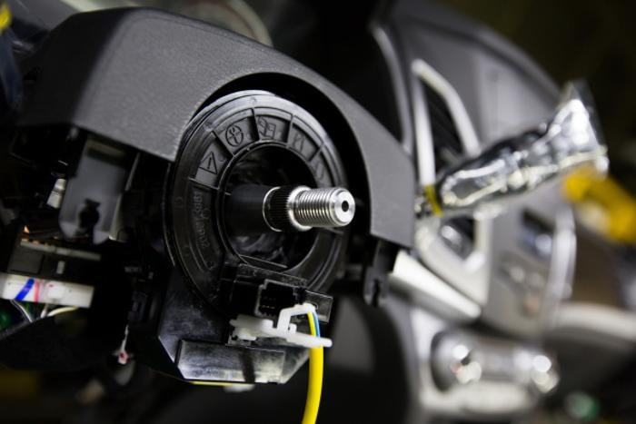

Minda Corporation Limited, a flagship company of Spark Minda, Ashok Minda Group made an initial investment in the manufacturing plant. The facility is equipped with Competency Centre for Excellence for Gravity Die Casting & Low Pressure Die Casting.

The Group has already received export order worth more than INR 100 crore of annual business for European Passenger Car Market.

N.K Taneja, Group Chief Marketing Officer, Spark Minda, Ashok Minda Group said, “Automotive industry is undergoing a huge overhaul with rising technological advancements where we see combined demands coming from National and International markets.  Inception of this new Die Casting facility under the umbrella of Spark Minda is a new milestone which will suffice product deliveries to various parts of world.”

Spark Minda, Ashok Minda Group, one of the leading manufacturers of automotive components for OEMs, is catering to the leading Passenger Vehicle, Commercial Vehicle, Motorcycle & Scooter, Off-road Vehicle & Tier 1 Manufacturers in India with presence in Germany, Poland, Czech Republic, Mexico, China, Indonesia, Vietnam, Uzbekistan and Japan.

Link - <https://www.alcircle.com/news/downstream-products/detail/29752/spark-minda-inaugurates-aluminium-die-casting-factory-in-pune>

|  |  |
| --- | --- |
| **Publication: Web India 123** | **Page No:** |
| **Edition: Online** | **Date: 08-02-2018** |

# Ashok Minda Group inaugurates Rs 100 cr die casting plant for 2 & 4 wheeler products

Pumping an initial investment of Rs 100 cr, Global Automotive Component Manufacturer 'Spark Minda, Ashok Minda Group' on Wednesday announced the inauguration of its state of the art Die Casting manufacturing plant at Chakan, Pune.

The Group has set up its third state of art Die Casting manufacturing facility exclusively for Aluminum Gravity Die Casting & Low Pressure Die Casting with machining in Pune for two and four wheeler products. The Group has already received significant export order worth more than Rs 100 Cr annual business for European Passenger Car Market.

Minda Corporation Limited, a flagship company of Spark Minda, Ashok Minda Group, made an initial investment of Rs 100 cr.

The Company already operates dedicated Aluminium and Zinc Die Casting machine components at their Greater Noida and Pune facilities for turbocharger system, braking system, handle mounting components and engine mounting components for the automotive market. Inauguration of third Die Casting plant in Pune will suffice the Indian as well export demands. The new facility is equipped with Competency Centre for Excellence for Gravity Die Casting & Low Pressure Die Casting. Mr. Ashok Minda, Group CEO, Spark Minda, Ashok Minda Group said, "Spark Minda follows a strict principle of Quality and Customer focus. We always cater in the best possible manner for our products and technological demands. Establishment of our new plant at Pune will enable Group to suffice the rising demand of Die Casting components for Indian & Global Automotive Customers. Mr. N.K Taneja, Group Chief Marketing Officer, Spark Minda, Ashok Minda Group said, "Automotive industry is undergoing a huge overhaul with rising technological advancements where we see combined demands coming from National and International markets. Minda Corporation Limited Executive Director & CEO Sudhir Kashyap said, "Year 2018 marks an exceptional start for Spark Minda, where we recently saw inauguration of our Technical Centre and now new Die Casting plant which will open new horizons for Group in components manufacturing.

Link - <https://news.webindia123.com/news/Articles/India/20180207/3270972.html>

|  |  |
| --- | --- |
| **Publication: This Week India** | **Page No:** |
| **Edition: Online** | **Date: 08-02-2018** |

SPARK MINDA Unveils Its Third Die Casting Plant at PUNE

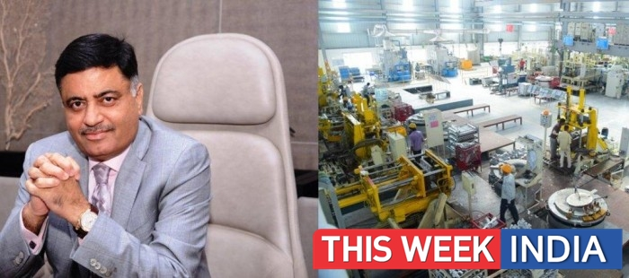

New Delhi, 07th February 2018: Global Automotive Component Manufacturer ‘SPARK MINDA, Ashok Minda Group’ (“Spark Minda” or “the Group”) today announced the inauguration of its state of the art Die Casting manufacturing plant at Chakan, Pune by its flagship company ‘Minda Corporation Limited’. The Group has set up its third state of art Die Casting manufacturing facility exclusively for Aluminum Gravity Die Casting & Low Pressure Die Casting with machining in Pune for two and four wheeler products.

MindaCorporation Limited (NSE: MINDACORP, BSE: 538962, a flagship company of SparkMinda, Ashok Minda Group) made an initial investment of Rs 100 cr. for new DieCasting manufacturing facility. The Company already operates dedicatedAluminium and Zinc Die Casting machine components at their Greater Noida andPune facilities for turbocharger system, braking system, handle mountingcomponents and engine mounting components for the automotive market.Inauguration of third Die Casting plant in Pune will suffice the Indian as wellexport demands. The new facility is equipped with Competency Centre forExcellence for Gravity Die Casting & Low Pressure Die Casting.

The Group has already received significant Exportorder worth more than Rs 100 Cr of annual business for European Passenger CarMarket.

***Mr.Ashok Minda, Group CEO, Spark Minda, Ashok Minda Group said****, “Spark Minda follows a strictprinciple of Quality and Customer focus. We always cater in the best possiblemanner for our products and technological demands. Establishment of ournew plant at Pune will enable Group to suffice the rising demand of Die Castingcomponents for Indian & Global Automotive Customers. We have pumped aninitial investment of Rs 100 cr, this investment will further escalate so as tocater the demands of automotive industry. We stand proud to serve our globalcustomers in the most distinct manner with a vision and mission to expandbeyond geographical boundaries”.*

***Mr.N.K Taneja, Group Chief Marketing Officer, Spark Minda, Ashok Minda Group said,****“Automotive industry isundergoing a huge overhaul with rising technological advancements where we seecombined demands coming from National and International markets. Inception of this new Die Casting facility under the umbrella of Spark Minda isa new milestone which will suffice product deliveries to various parts ofworld. Spark Minda has been strong player in Gravity Die Casting, continuingthe legacy the new plant will develop and integrate products with our recentlyinaugurated Technical Centre (Spark Minda Technical Centre - SMIT) located atChakan, Pune.”*

***MrSudhir Kashyap, Executive Director & CEO, Minda Corporation Limitedsaid,****“Year2018 marks an exceptional start for Spark Minda, where we recently sawinauguration of our Technical Centre and now new Die Casting plant which willopen new horizons for Group in components manufacturing. We have dynamicallyaligned our technological processes with product development to establish atrade mark of superiority in the products we develop and manufacture. Weoperate on simple DNA of “Powered by Passion” and we are confident enough totake our capabilities to another level with each passing year”.*

Link - <https://thisweekindia.news/article/spark-minda-unveils-its-third-die-casting-plant-at-pune/12284>

|  |  |
| --- | --- |
| **Publication: Mumbai News Network** | **Page No:** |
| **Edition: Online** | **Date: 08-02-2018** |

# [SPARK MINDA Unveils Its Third Die Casting Plant at PUNE](https://mumbainewsnetwork.blogspot.com/2018/02/spark-minda-unveils-its-third-die.html)

[](https://2.bp.blogspot.com/-9T-R2oIqk8o/Wns56vmV7-I/AAAAAAABYSo/ZZCzdYO-QW4eOdmngy76--GFYXoNt9VuwCLcBGAs/s1600/Mr.+Ashok+Minda,+Group+CEO,+Spark+Minda+Group.JPG)

Spark Minda, Ashok Minda Group inaugurates its third Die Casting plant at Pune, takes a significant leap towards investment in Aluminium Die-Casting to foresee huge potential & spur demand from growing Indian & Global Automotive Industry.

**Key Highlights of the Plant:**

* Competency Centre for Excellence - Gravity Die Casting & Low Pressure Die Casting with High precision Machining Centre and Powder Coating.
* Well-equipped Test Lab with added facilities like X-Ray, Metallurgy & Mechanical and Environmental test equipment’s**.**
* Spread over 10 acre land, the new plant expects incremental sales of **Rs. 200 cr per annum** in next couple of years, total order booked for this plant of approx. **Rs. 175 cr per annum.**
* existing production capacity for Die Casting Division is 8,500 MT p.a. and for FY 2018-19 target is 9,700 MT p.a.
* **Initial Capital investment of Rs. 100 cr in Phase -1.**

**New Delhi, 07th February 2018**: Global Automotive Component Manufacturer ‘SPARK MINDA, Ashok Minda Group’ (“Spark Minda” or “the Group”) today announced the inauguration of its state of the art Die Casting manufacturing plant at Chakan, Pune by its flagship company ‘Minda Corporation Limited’. The Group has set up its third state of art Die Casting manufacturing facility exclusively for Aluminum Gravity Die Casting & Low Pressure Die Casting with machining in Punefor two and four wheeler products.

Minda Corporation Limited (NSE: MINDACORP, BSE: 538962, a flagship company of Spark Minda, Ashok Minda Group) made an initial investment of Rs 100 cr. for new Die Casting manufacturing facility. The Company already operates dedicated Aluminium and Zinc Die Casting machine components at their Greater Noida and Pune facilities for turbocharger system, braking system, handle mounting components and engine mounting components for the automotive market. Inauguration of third Die Casting plant in Pune will suffice the Indian as well export demands. The new facility is equipped with Competency Centre for Excellence for Gravity Die Casting & Low Pressure Die Casting.

The Group has already received significant Export order worth more than Rs 100 Cr of annual business for European Passenger Car Market.

***Mr. Ashok Minda, Group CEO, Spark Minda, Ashok Minda Group said****, “Spark Minda follows a strict principle of Quality and Customer focus. We always cater in the best possible manner for our products and technological demands. Establishment of our new plant at Pune will enable Group to suffice the rising demand of Die Casting components for Indian & Global Automotive Customers. We have pumped an initial investment of Rs 100 cr, this investment will further escalate so as to cater the demands of automotive industry. We stand proud to serve our global customers in the most distinct manner with a vision and mission to expand beyond geographical boundaries”.*

***Mr. N.K Taneja, Group Chief Marketing Officer, Spark Minda, Ashok Minda Group said,****“Automotive industry is undergoing a huge overhaul with rising technological advancements where we see combined demands coming from National and International markets.  Inception of this new Die Casting facility under the umbrella of Spark Minda is a new milestone which will suffice product deliveries to various parts of world. Spark Minda has been strong player in Gravity Die Casting, continuing the legacy the new plant will develop and integrate products with our recently inaugurated Technical Centre (Spark Minda Technical Centre - SMIT) located at Chakan, Pune.”*

***Mr Sudhir Kashyap, Executive Director & CEO, Minda Corporation Limited said,****“Year 2018 marks an exceptional start for Spark Minda, where we recently saw inauguration of our Technical Centre and now new Die Casting plant which will open new horizons for Group in components manufacturing. We have dynamically aligned our technological processes with product development to establish a trade mark of superiority in the products we develop and manufacture. We operate on simple DNA of “Powered by Passion” and we are confident enough to take our capabilities to another level with each passing year”.*

Spark Minda, Ashok Minda Group’s legacy goes back to 1958 when the first operation was set up in India. Today, 60 years later, Spark Minda has 35 manufacturing facilities world-wide, and provides direct employment to more than  16,000 people and indirect employment to several thousands more. Over the past few years, Spark Minda, Ashok Minda Group has done strategic acquisitions in Germany & Poland along with green-field projects in Indonesia, Vietnam, Uzbekistan and Czech Republic. Our recent endeavours include; setting up a new manufacturing facility at Mexico, besides acquisition of EI LABS India Pvt. Ltd. which will further enhance our Group’s expertise in Connected Mobility and IoT Solutions. The Group has also inaugurated its R&D centre at Pune– Spark Minda Technical Centre (SMIT) which takes a significant leap towards investment in technology leadership and creates a robust platform to emerge as a System Solution provider in the growing automotive industry.

The Group has made several fruitful and successful Joint Ventures/ relationships with the best of the automotive industry players around the world in the domain of designing and manufacturing namely; Stoneridge of USA, VAST of USA, SBHAP of China, SILCA of Italy, Furukawa of Japan & UzAvto of Uzbekistan as our JV Partners. We are privileged to serve Global OEM players such as VW Group, BMW, Daimler, Ford, Renault Nissan, General Motors and so on. In India, our prestigious customer names include the leading OEM’s such as Mahindra, TATA Motors, Ashok Leyland, Honda, Renault Nissan, Maruti Suzuki, Bajaj, Yamaha, TVS etc. We are also catering to Tier-1 Customers such as Honeywell, BorgWarner, Bosch, Brembo, Delphi, Cummins besides others. Our growth oriented initiatives and relationship with some of the most reputed OEM manufacturers have enabled us to report strong growth over the year.

Link - <https://mumbainewsnetwork.blogspot.in/2018/02/spark-minda-unveils-its-third-die.html>

|  |  |
| --- | --- |
| **Publication: Manufacturing Industry** | **Page No:** |
| **Edition: Online** | **Date: 08-02-2018** |

SPARK MINDA Unveils Its Third Die Casting Plant at PUNE

Spark Minda, Ashok Minda Group inaugurates its third Die Casting plant at Pune, takes a significant leap towards investment in Aluminium Die-Casting to foresee huge potential & spur demand from growing Indian & Global Automotive Industry.

**Key Highlights of the Plant:**

* Competency Centre for Excellence – Gravity Die Casting & Low Pressure Die Casting with High precision Machining Centre and Powder Coating.
* Well-equipped Test Lab with added facilities like X-Ray, Metallurgy & Mechanical and Environmental test equipment’s**.**
* Spread over 10 acre land, the new plant expects incremental sales of **Rs. 200 cr per annum** in next couple of years, total order booked for this plant of approx. **Rs. 175 cr per annum.**
* existing production capacity for Die Casting Division is 8,500 MT p.a. and for FY 2018-19 target is 9,700 MT p.a.
* **Initial Capital investment of Rs. 100 cr in Phase -1.**

 Global Automotive Component Manufacturer ‘SPARK MINDA, Ashok Minda Group’ (“Spark Minda” or “the Group”) today announced the inauguration of its state of the art Die Casting manufacturing plant at Chakan, Pune by its flagship company ‘Minda Corporation Limited’. The Group has set up its third state of art Die Casting manufacturing facility exclusively for Aluminum Gravity Die Casting & Low Pressure Die Casting with machining in Pune for two and four wheeler products.

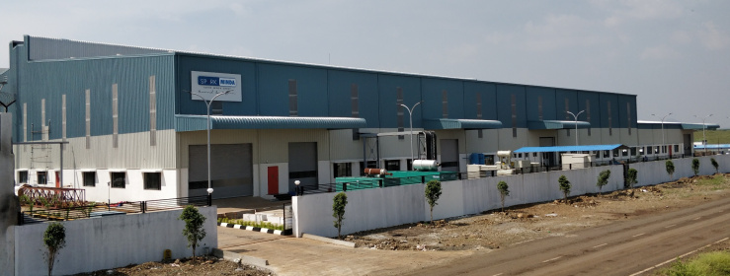

Minda Corporation Limited (NSE: MINDACORP, BSE: 538962, a flagship company of Spark Minda, Ashok Minda Group) made an initial investment of Rs 100 cr. for new Die Casting manufacturing facility. The Company already operates dedicated Aluminium and Zinc Die Casting machine components at their Greater Noida and Pune facilities for turbocharger system, braking system, handle mounting components and engine mounting components for the automotive market. Inauguration of third Die Casting plant in Pune will suffice the Indian as well export demands. The new facility is equipped with Competency Centre for Excellence for Gravity Die Casting & Low Pressure Die Casting.The Group has already received significant Export order worth more than Rs 100 Cr of annual business for European Passenger Car Market.

***Mr. Ashok Minda, Group CEO, Spark Minda, Ashok Minda Group said****, “Spark Minda follows a strict principle of Quality and Customer focus. We always cater in the best possible manner for our products and technological demands. Establishment of our new plant at Pune will enable Group to suffice the rising demand of Die Casting components for Indian & Global Automotive Customers. We have pumped an initial investment of Rs 100 cr, this investment will further escalate so as to cater the demands of automotive industry. We stand proud to serve our global customers in the most distinct manner with a vision and mission to expand beyond geographical boundaries”.*

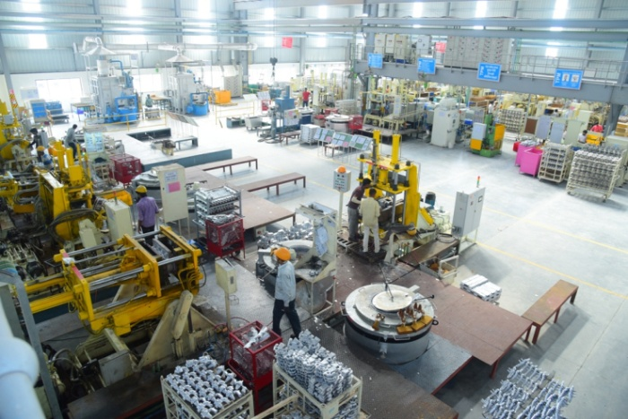

***Mr. N.K Taneja, Group Chief Marketing Officer, Spark Minda, Ashok Minda Group said,****“Automotive industry is undergoing a huge overhaul with rising technological advancements where we see combined demands coming from National and International markets.  Inception of this new Die Casting facility under the umbrella of Spark Minda is a new milestone which will suffice product deliveries to various parts of world. Spark Minda has been strong player in Gravity Die Casting, continuing the legacy the new plant will develop and integrate products with our recently inaugurated Technical Centre (Spark Minda Technical Centre – SMIT) located at Chakan, Pune.”*

***Mr Sudhir Kashyap, Executive Director & CEO, Minda Corporation Limited said,****“Year 2018 marks an exceptional start for Spark Minda, where we recently saw inauguration of our Technical Centre and now new Die Casting plant which will open new horizons for Group in components manufacturing. We have dynamically aligned our technological processes with product development to establish a trade mark of superiority in the products we develop and manufacture. We operate on simple DNA of “Powered by Passion” and we are confident enough to take our capabilities to another level with each passing year”.*



Link - <https://manufacturingunits.wordpress.com/2018/02/08/spark-minda-unveils-its-third-die-casting-plant-at-pune/>

|  |  |
| --- | --- |
| **Publication: NRI News 24 * 7** | **Page No:** |
| **Edition: Online** | **Date: 08-02-2018** |

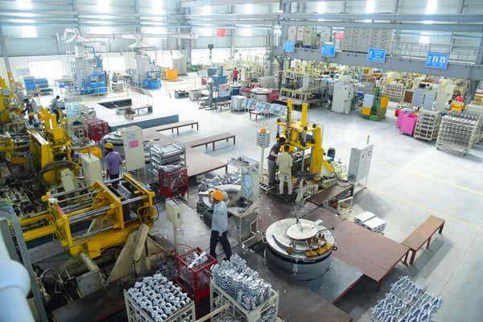

# SPARK MINDA Unveils Its Third Die Casting Plant at PUNE

**New Delhi**: Global Automotive Component Manufacturer ‘SPARK MINDA, Ashok Minda Group’ (“Spark Minda” or “the Group”) today announced the inauguration of its state of the art Die Casting manufacturing plant at Chakan, Pune by its flagship company ‘Minda Corporation Limited’. The Group has set up its third state of art Die Casting manufacturing facility exclusively for Aluminum Gravity Die Casting & Low Pressure Die Casting with machining in Pune for two and four wheeler products.

Minda Corporation Limited (NSE: MINDACORP, BSE: 538962, a flagship company of Spark Minda, Ashok Minda Group) made an initial investment of Rs 100 cr. for new Die Casting manufacturing facility. The Company already operates dedicated Aluminium and Zinc Die Casting machine components at their Greater Noida and Pune facilities for turbocharger system, braking system, handle mounting components and engine mounting components for the automotive market. Inauguration of third Die Casting plant in Pune will suffice the Indian as well export demands. The new facility is equipped with Competency Centre for Excellence for Gravity Die Casting & Low Pressure Die Casting.

The Group has already received significant Export order worth more than Rs 100 Cr of annual business for European Passenger Car Market.

**Mr. Ashok Minda, Group CEO, Spark Minda, Ashok Minda Group said**, “Spark Minda follows a strict principle of Quality and Customer focus. We always cater in the best possible manner for our products and technological demands. Establishment of our new plant at Pune will enable Group to suffice the rising demand of Die Casting components for Indian & Global Automotive Customers. We have pumped an initial investment of Rs 100 cr, this investment will further escalate so as to cater the demands of automotive industry. We stand proud to serve our global customers in the most distinct manner with a vision and mission to expand beyond geographical boundaries”.

**Mr. N.K Taneja, Group Chief Marketing Officer, Spark Minda, Ashok Minda Group said,**“Automotive industry is undergoing a huge overhaul with rising technological advancements where we see combined demands coming from National and International markets.  Inception of this new Die Casting facility under the umbrella of Spark Minda is a new milestone which will suffice product deliveries to various parts of world. Spark Minda has been strong player in Gravity Die Casting, continuing the legacy the new plant will develop and integrate products with our recently inaugurated Technical Centre (Spark Minda Technical Centre – SMIT) located at Chakan, Pune.”

**Mr Sudhir Kashyap, Executive Director & CEO, Minda Corporation Limited said,**“Year 2018 marks an exceptional start for Spark Minda, where we recently saw inauguration of our Technical Centre and now new Die Casting plant which will open new horizons for Group in components manufacturing. We have dynamically aligned our technological processes with product development to establish a trade mark of superiority in the products we develop and manufacture. We operate on simple DNA of “Powered by Passion” and we are confident enough to take our capabilities to another level with each passing year”.

Link - <http://nrinews24x7.com/spark-minda-unveils-third-die-casting-plant-pune/>

|  |  |
| --- | --- |
| **Publication: Noshwind** | **Page No:** |
| **Edition: Online** | **Date: 08-02-2018** |

SPARK MINDA Unveils Its Third Die Casting Plant at PUNE

Spark Minda, Ashok Minda Group inaugurates its third Die Casting plant at Pune, takes a significant leap towards investment in Aluminium Die-Casting to foresee huge potential & spur demand from growing Indian & Global Automotive Industry.

**Key Highlights of the Plant:**

* Competency Centre for Excellence - Gravity Die Casting & Low Pressure Die Casting with High precision Machining Centre and Powder Coating.
* Well-equipped Test Lab with added facilities like X-Ray, Metallurgy & Mechanical and Environmental test equipment’s**.**
* Spread over 10 acre land, the new plant expects incremental sales of **Rs. 200 cr per annum** in next couple of years, total order booked for this plant of approx. **Rs. 175 cr per annum.**
* existing production capacity for Die Casting Division is 8,500 MT p.a. and for FY 2018-19 target is 9,700 MT p.a.
* **Initial Capital investment of Rs. 100 cr in Phase -1.**

**New Delhi, 07th February 2018**: Global Automotive Component Manufacturer ‘SPARK MINDA, Ashok Minda Group’ (“Spark Minda” or “the Group”) today announced the inauguration of its state of the art Die Casting manufacturing plant at Chakan, Pune by its flagship company ‘Minda Corporation Limited’. The Group has set up its third state of art Die Casting manufacturing facility exclusively for Aluminum Gravity Die Casting & Low Pressure Die Casting with machining in Punefor two and four wheeler products.

Minda Corporation Limited (NSE: MINDACORP, BSE: 538962, a flagship company of Spark Minda, Ashok Minda Group) made an initial investment of Rs 100 cr. for new Die Casting manufacturing facility. The Company already operates dedicated Aluminium and Zinc Die Casting machine components at their Greater Noida and Pune facilities for turbocharger system, braking system, handle mounting components and engine mounting components for the automotive market. Inauguration of third Die Casting plant in Pune will suffice the Indian as well export demands. The new facility is equipped with Competency Centre for Excellence for Gravity Die Casting & Low Pressure Die Casting.

The Group has already received significant Export order worth more than Rs 100 Cr of annual business for European Passenger Car Market.

***Mr. Ashok Minda, Group CEO, Spark Minda, Ashok Minda Group said****, “Spark Minda follows a strict principle of Quality and Customer focus. We always cater in the best possible manner for our products and technological demands. Establishment of our new plant at Pune will enable Group to suffice the rising demand of Die Casting components for Indian & Global Automotive Customers. We have pumped an initial investment of Rs 100 cr, this investment will further escalate so as to cater the demands of automotive industry. We stand proud to serve our global customers in the most distinct manner with a vision and mission to expand beyond geographical boundaries”.*

***Mr. N.K Taneja, Group Chief Marketing Officer, Spark Minda, Ashok Minda Group said,****“Automotive industry is undergoing a huge overhaul with rising technological advancements where we see combined demands coming from National and International markets.  Inception of this new Die Casting facility under the umbrella of Spark Minda is a new milestone which will suffice product deliveries to various parts of world. Spark Minda has been strong player in Gravity Die Casting, continuing the legacy the new plant will develop and integrate products with our recently inaugurated Technical Centre (Spark Minda Technical Centre - SMIT) located at Chakan, Pune.”*

***Mr Sudhir Kashyap, Executive Director & CEO, Minda Corporation Limited said,****“Year 2018 marks an exceptional start for Spark Minda, where we recently saw inauguration of our Technical Centre and now new Die Casting plant which will open new horizons for Group in components manufacturing. We have dynamically aligned our technological processes with product development to establish a trade mark of superiority in the products we develop and manufacture. We operate on simple DNA of “Powered by Passion” and we are confident enough to take our capabilities to another level with each passing year”.*

Link - <http://nooshwinds.blogspot.in/2018/02/spark-minda-unveils-its-third-die.html>

|  |  |
| --- | --- |
| **Publication: Auto Tech Review** | **Page No:** |
| **Edition: Online** | **Date: 12-02-2018** |



**Spark Minda Opens Third Die Casting Plant At Pune**

Spark Minda, Ashok Minda Group inaugurated its third die casting plant at Chakan, Pune. This new plant will be exclusively for aluminium gravity die casting and low pressure die casting, with machining in Pune for two and four-wheeler products. The plant inauguration was initiated by its flagship company Minda Corporation Ltd.

Minda Corporation Limited - a flagship company of Spark Minda, Ashok Minda Group – has put in an initial investment of Rs 100 crore for the new die casting manufacturing facility. The company already operates dedicated aluminium and zinc die casting machine components at its Greater Noida and Pune facilities for turbocharger system, braking system, handle mounting components and engine mounting components for the automotive market. The new plant in Pune is equipped with a Competency Centre for Excellence, for gravity die casting and low pressure die casting. This plant has been set up to meet Indian, as well as export demands.

Ashok Minda, Group CEO, Spark Minda, Ashok Minda Group, said the company follows a strict principle of quality and customer focus, serving in the best possible manner for products and technological demands. He added that the new plant will enable the Group to meet the rising demand for die casting components for Indian and global automotive customers.

2018 has marked a good start for Spark Minda, with the recent inauguration of its technical centre, followed by the new die casting plant, noted Sudhir Kashyap, Executive Director and CEO, Minda Corporation Ltd. He said the company has dynamically aligned its technological processes with product development to ensure product superiority.

Link - <https://autotechreview.com/news/spark-minda-opens-third-die-casting-plant-at-pune>

|  |  |
| --- | --- |
| **Publication: Auto Breaking News** | **Page No:** |
| **Edition: Online** | **Date: 12-02-2018** |



**Spark Minda opens third die casting plant in Pune**

The Spark Minda, Ashok Minda Group has inaugurated its new state-of-the-art die casting manufacturing plant at Chakan, Pune by its flagship company Minda Corporation. The Group’s third die casting facility is exclusively for aluminium gravity die casting and low pressure die casting with machining in Pune for two- and four-wheelers.   Minda Corporation has made an initial investment of Rs 100 crore in the new unit. The company already produces aluminium and zinc die casting machine components at its Greater Noida and Pune facilities for turbocharger systems, braking systems, handle mounting components and engine mounting components. The new plant, which is equipped with a Competency Centre for Excellence for Gravity Die Casting and Low Pressure Die Casting, in Pune will cater to both the domestic market and exports.

The Group has already received significant export orders worth more than Rs 100 crore of annual business from the European passenger car market. Ashok Minda, Group CEO, Spark Minda, Ashok Minda Group (pictured above) said, “Spark Minda follows a strict principle of quality and customer focus. We always cater in the best possible manner for our products and technological demands. Establishment of our new plant at Pune will enable the Group to cater to the rising demand for die casting components for Indian and global automotive customers.” N K Taneja, Group chief marketing officer, said, “The automotive industry is undergoing a huge overhaul with rising technological advancements where we see combined demand coming from national and international markets. Spark Minda has been a strong player in

Link - <https://www.autobreakingnews.com/2018/02/spark-minda-opens-third-die-casting-plant-in-pune/>