

***SPARK MINDA & INFAC-SOUTH KOREA Signs Technical Assistance Agreement for Vehicle Antenna Systems***

**Media Coverage Report  
August 2019**

|  |  |
| --- | --- |
| **Publication: The Hindu Business Line** | **Page No: 05** |
| **Edition: All Editions** | **Date: 14-08-2019** |

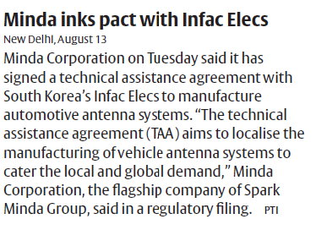

|  |  |
| --- | --- |
| **Publication: The Free Press Journal** | **Page No: 19** |
| **Edition: Mumbai Indore Bhopal** | **Date: 14-08-2019** |

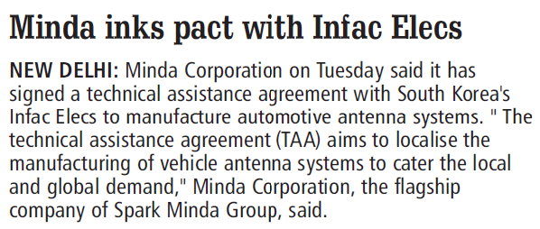

|  |  |
| --- | --- |
| **Publication: Telegana Today** | **Page No: 13** |
| **Edition: Hyderabad** | **Date: 14-08-2019** |

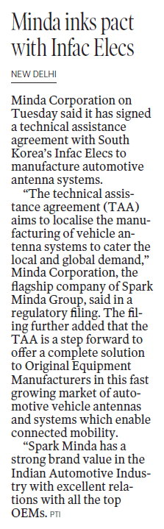

|  |  |
| --- | --- |
| **Publication: ET Gujarati** | **Page No: 01** |
| **Edition: Mumbai and Ahmedabad** | **Date: 14-08-2019** |

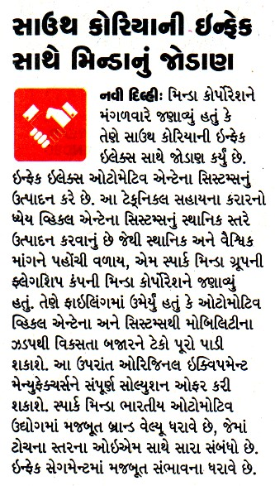

|  |  |
| --- | --- |
| **Publication: Dainik Yashobhoomi** | **Page No: 09** |
| **Edition: Mumbai** | **Date: 14-08-2019** |

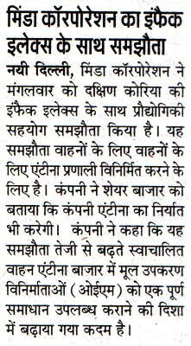

|  |  |
| --- | --- |
| **Publication: Pioneer Hindi** | **Page No: 12** |
| **Edition: New Delhi** | **Date: 14-08-2019** |

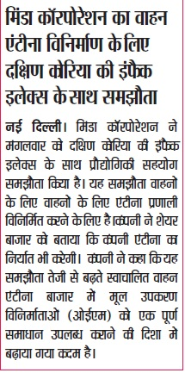

|  |  |
| --- | --- |
| **Publication: People’s Samachar** | **Page No: 12** |
| **Edition: Indore** | **Date: 14-08-2019** |

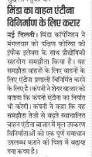

|  |  |
| --- | --- |
| **Publication: PTI** | **Page No:** |
| **Edition: National** | **Date: 13-08-2019** |

**Minda inks pact with South Korea's Infac Elecs to manufacture vehicle antenna systems**

New Delhi, Aug 13 (PTI) Minda Corporation on Tuesday said it has signed a technical assistance agreement with South Korea's Infac Elecs to manufacture automotive antenna systems.

"The technical assistance agreement (TAA) aims to localise the manufacturing of vehicle antenna systems to cater the local and global demand," Minda Corporation, the flagship company of Spark Minda Group, said in a regulatory filing.

The filing further added that the TAA is a step forward to offer a complete solution to Original Equipment Manufacturers (OEMs) in this fast growing market of automotive vehicle antennas and systems which enable connected mobility.

"Spark Minda has a strong brand value in the Indian Automotive Industry with excellent relations with all the top OEMs. With Infac's strong capability in this segment, this alliance would leverage each other's strengths and help in establishing a strong business for antenna systems in India," the company added.

|  |  |
| --- | --- |
| **Publication: UNI** | **Page No:** |
| **Edition: National** | **Date: 13-08-2019** |



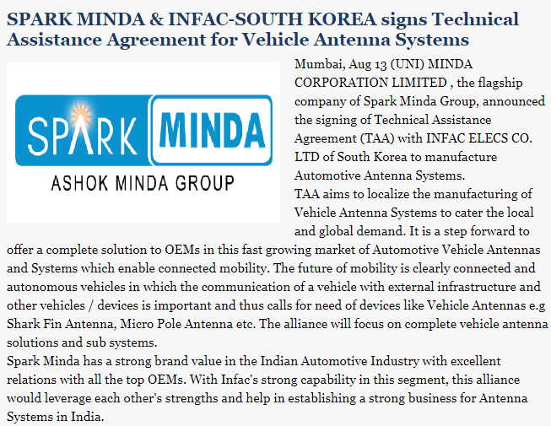

Link - <http://www.uniindia.com/spark-minda-infac-south-korea-signs-technical-assistance-agreement-for-vehicle-antenna-systems/business-economy/news/1696706.html>

|  |  |
| --- | --- |
| **Publication: ET Auto** | **Page No:** |
| **Edition: Online** | **Date: 14-08-2019** |



**Minda inks pact with South Korea's Infac Elecs to manufacture vehicle antenna systems**

New Delhi, Aug 13 (PTI) Minda Corporation on Tuesday said it has signed a technical assistance agreement with South Korea's Infac Elecs to manufacture automotive antenna systems.

"The technical assistance agreement (TAA) aims to localise the manufacturing of vehicle antenna systems to cater the local and global demand," Minda Corporation, the flagship company of Spark Minda Group, said in a regulatory filing.

The filing further added that the TAA is a step forward to offer a complete solution to Original Equipment Manufacturers (OEMs) in this fast growing market of automotive vehicle antennas and systems which enable connected mobility.

"Spark Minda has a strong brand value in the Indian Automotive Industry with excellent relations with all the top OEMs. With Infac's strong capability in this segment, this alliance would leverage each other's strengths and help in establishing a strong business for antenna systems in India," the company added.

Link - <https://auto.economictimes.indiatimes.com/news/auto-components/minda-inks-pact-with-south-koreas-infac-elecs-to-manufacture-vehicle-antenna-systems/70670424>

|  |  |
| --- | --- |
| **Publication: Business Standard** | **Page No:** |
| **Edition: Online** | **Date: 14-08-2019** |

Business Standard

**Minda inks pact with South Korea's Infac Elecs to manufacture vehicle antenna systems**

New Delhi, Aug 13 (PTI) Minda Corporation on Tuesday said it has signed a technical assistance agreement with South Korea's Infac Elecs to manufacture automotive antenna systems.

"The technical assistance agreement (TAA) aims to localise the manufacturing of vehicle antenna systems to cater the local and global demand," Minda Corporation, the flagship company of Spark Minda Group, said in a regulatory filing.

The filing further added that the TAA is a step forward to offer a complete solution to Original Equipment Manufacturers (OEMs) in this fast growing market of automotive vehicle antennas and systems which enable connected mobility.

"Spark Minda has a strong brand value in the Indian Automotive Industry with excellent relations with all the top OEMs. With Infac's strong capability in this segment, this alliance would leverage each other's strengths and help in establishing a strong business for antenna systems in India," the company added.

Link - <https://www.business-standard.com/article/news-cm/minda-corporation-signs-technical-assistance-agreement-with-infac-elecs-co-south-korea-119081300168_1.html>

|  |  |
| --- | --- |
| **Publication: Money Control** | **Page No:** |
| **Edition: Online** | **Date: 14-08-2019** |



**Minda inks pact with South Korea's Infac Elecs to manufacture vehicle antenna systems**

New Delhi, Aug 13 (PTI) Minda Corporation on Tuesday said it has signed a technical assistance agreement with South Korea's Infac Elecs to manufacture automotive antenna systems.

"The technical assistance agreement (TAA) aims to localise the manufacturing of vehicle antenna systems to cater the local and global demand," Minda Corporation, the flagship company of Spark Minda Group, said in a regulatory filing.

The filing further added that the TAA is a step forward to offer a complete solution to Original Equipment Manufacturers (OEMs) in this fast growing market of automotive vehicle antennas and systems which enable connected mobility.

"Spark Minda has a strong brand value in the Indian Automotive Industry with excellent relations with all the top OEMs. With Infac's strong capability in this segment, this alliance would leverage each other's strengths and help in establishing a strong business for antenna systems in India," the company added.

Link - <https://www.moneycontrol.com/news/business/companies/minda-corp-inks-pact-with-south-koreas-infac-elecs-to-manufacture-vehicle-antenna-systems-4329091.html>

|  |  |
| --- | --- |
| **Publication: News 18** | **Page No:** |
| **Edition: Online** | **Date: 14-08-2019** |

Auto

**Minda inks pact with South Korea's Infac Elecs to manufacture vehicle antenna systems**

New Delhi, Aug 13 (PTI) Minda Corporation on Tuesday said it has signed a technical assistance agreement with South Korea's Infac Elecs to manufacture automotive antenna systems.

"The technical assistance agreement (TAA) aims to localise the manufacturing of vehicle antenna systems to cater the local and global demand," Minda Corporation, the flagship company of Spark Minda Group, said in a regulatory filing.

The filing further added that the TAA is a step forward to offer a complete solution to Original Equipment Manufacturers (OEMs) in this fast growing market of automotive vehicle antennas and systems which enable connected mobility.

"Spark Minda has a strong brand value in the Indian Automotive Industry with excellent relations with all the top OEMs. With Infac's strong capability in this segment, this alliance would leverage each other's strengths and help in establishing a strong business for antenna systems in India," the company added.

Link - <https://www.news18.com/news/auto/minda-corporation-south-koreas-infac-elecs-co-to-manufacture-vehicle-antenna-systems-2268735.html>

|  |  |
| --- | --- |
| **Publication: Auto Tech Review** | **Page No:** |
| **Edition: Online** | **Date: 14-08-2019** |

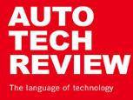

# Minda Corporation, Infac Elecs to Jointly Develop New Antenna Systems

Minda Corporation and Infac Elecs Co Ltd. have joined hands to sign a Technical Assistance Agreement (TAA) to manufacture automotive antenna systems for both local and global demand. The new agreement will precisely focus on complete vehicle antenna solutions and sub-systems development and both companies will leverage each other’s strengths to set up a strong base for antenna systems in India.

Under the TAA, both the companies aim to serve the connected and autonomous vehicles that are poised to take off like never before in coming times. Vehicle communication with external infrastructure and other vehicles moving in vicinity will call for development of various new antenna systems and sub-systems micro pole antenna, shark finn antenna, etc.

Ashok Minda, Chairman & Group CEO, Spark Minda, said the TAA will strengthen the company’s entry into connected mobility market through localised manufacturing in India with Infac's expertise and technological capability.

Woongseon Choi, Group CEO, Infac, said both companies will seek various means to generate business synergies through mutual collaboration under the TAA.

Link <https://autotechreview.com/news/minda-corporation-infac-elecs-co-ltd-new-antenna-shark-finn-antenna-micro-pole-antenna-connected-mobility-autonomous-vehicles>

|  |  |
| --- | --- |
| **Publication: Devdiscourse** | **Page No:** |
| **Edition: Online** | **Date: 14-08-2019** |



**Minda inks pact with South Korea's Infac Elecs to manufacture vehicle antenna systems**

New Delhi, Aug 13 (PTI) Minda Corporation on Tuesday said it has signed a technical assistance agreement with South Korea's Infac Elecs to manufacture automotive antenna systems.

"The technical assistance agreement (TAA) aims to localise the manufacturing of vehicle antenna systems to cater the local and global demand," Minda Corporation, the flagship company of Spark Minda Group, said in a regulatory filing.

The filing further added that the TAA is a step forward to offer a complete solution to Original Equipment Manufacturers (OEMs) in this fast growing market of automotive vehicle antennas and systems which enable connected mobility.

"Spark Minda has a strong brand value in the Indian Automotive Industry with excellent relations with all the top OEMs. With Infac's strong capability in this segment, this alliance would leverage each other's strengths and help in establishing a strong business for antenna systems in India," the company added.

Link - <https://www.devdiscourse.com/article/business/631855-minda-inks-pact-with-south-koreas-infac-elecs-to-manufacture-vehicle-antenna-systems>

|  |  |
| --- | --- |
| **Publication: Autocar Professional** | **Page No:** |
| **Edition: Online** | **Date: 14-08-2019** |



# Spark Minda strikes tech alliance with South Korea's Infac Elecs for antenna systems

[AUTO COMPONENTS](https://www.autocarpro.in/category/auto-components)

By Nilesh Wadhwa 12 Aug 2019

**Domestic component major Spark Minda, Ashok Minda Group is looking to make smart gains and has been working on a aggressive roadmap that calls for achieving improved efficiencies and growth through organic and inorganic routes.**

The Tier 1 supplier today announced that the company's board has approved Technical Assistance Agreement (TAA) with South Korea-based Infac Elecs to manufacture automotive antenna systems.

The Korean company has gradually expanded its business to control cables, antennas, horns and actuators. In fact, the company also makes cell cases for electric and hybrid vehicles. In fact, on August 15, 1998 the company set up its first facility in India at Kanchipuram, Tamil Nadu, where it produces control cables, battery cables, ignition cables, feeder cables, and supplies them to Hyundai Motor India, Hyundai Mobis, Turkey, HAOS, GMI, and Volkswagen. Infac India expanded its plant in January 2012 to establish a production base for stable product supply.

Earlier last week, the company has announced to [amalgamate five of its domestic subsidiaries](https://www.autocarpro.in/news-national/minda-corp-to-merge-five-subsidiaries-to-cut-costs-and-increase-efficiencies-43749) — Minda Management Services, Minda SAI, Minda Automotive Solutions, Minda Autoelektrik and Minda Telematics & Electric Mobility Solutions into Minda Corp. The move will result in consolidation of its businesses and facilitate greater synergies, enabling them to have access to wider financial resources, increase managerial efficiencies, lower the cost structure and allow for higher transparency.

Link - <https://www.autocarpro.in/news-national/spark-minda-strikes-tech-alliance-with-south-korea-infac-elecs-43807>

|  |  |
| --- | --- |
| **Publication: Outlook** | **Page No:** |
| **Edition: Online** | **Date: 14-08-2019** |

https://www.outlookindia.com/new/images/newsscroll/logo.jpg

**Minda inks pact with South Korea's Infac Elecs to manufacture vehicle antenna systems**

New Delhi, Aug 13 (PTI) Minda Corporation on Tuesday said it has signed a technical assistance agreement with South Korea's Infac Elecs to manufacture automotive antenna systems.

"The technical assistance agreement (TAA) aims to localise the manufacturing of vehicle antenna systems to cater the local and global demand," Minda Corporation, the flagship company of Spark Minda Group, said in a regulatory filing.

The filing further added that the TAA is a step forward to offer a complete solution to Original Equipment Manufacturers (OEMs) in this fast growing market of automotive vehicle antennas and systems which enable connected mobility.

"Spark Minda has a strong brand value in the Indian Automotive Industry with excellent relations with all the top OEMs. With Infac's strong capability in this segment, this alliance would leverage each other's strengths and help in establishing a strong business for antenna systems in India," the company added.

Link - <https://www.outlookindia.com/newsscroll/minda-inks-pact-with-south-koreas-infac-elecs-to-manufacture-vehicle-antenna-systems/1595747>

|  |  |
| --- | --- |
| **Publication: Equity Bulls** | **Page No:** |
| **Edition: Online** | **Date: 14-08-2019** |



**SPARK MINDA & INFAC-SOUTH KOREA Signs Technical Assistance Agreement for Vehicle Antenna Systems**

Posted On: 2019-08-13 09:33:07

MINDA CORPORATION LIMITED (referred to as "Minda Corp"; NSE: MINDACORP, BSE: 538962), the flagship company of Spark Minda Group, announced the signing of Technical Assistance Agreement (TAA) with INFAC ELECS CO. LTD of South Korea to manufacture Automotive Antenna Systems.

TAA aims to localize the manufacturing of Vehicle Antenna Systems to cater the local and global demand. It is a step forward to offer a complete solution to OEMs in this fast growing market of Automotive Vehicle Antennas and Systems which enable connected mobility. The future of mobility is clearly connected and autonomous vehicles in which the communication of a vehicle with external infrastructure and other vehicles / devices is important and thus calls for need of devices like Vehicle Antennas e.g Shark Fin Antenna, Micro Pole Antenna etc. The alliance will focus on complete vehicle antenna solutions and sub systems.

Spark Minda has a strong brand value in the Indian Automotive Industry with excellent relations with all the top OEMs. With Infac's strong capability in this segment, this alliance would leverage each other's strengths and help in establishing a strong business for Antenna Systems in India.

Commenting on the signing, Mr. Ashok Minda, Chairman and Group CEO of Spark Minda, said: "This cooperation would mark the inception of a long lasting relationship with INFAC, one of the leading global manufacturers of Vehicle Antenna Systems. This engagement will enable & strengthen Spark Minda Group's entry into connected mobility market through localized manufacturing in India with the support of INFAC's strong technological capability & global presence. India is becoming one of the most preferred hubs for the automotive industry. This alliance will leverage Spark Minda's strong relationship with leading OEMs thus marking our entry into this attractive Vehicle Antenna System Market".

Commenting on the signing, Mr. Woongseon Choi, Group CEO of Infac: "India is the market which has lots of chances and possibilities, especially in the automotive industry. Thus Infac has been making an effort for India market from early on. I am so glad to take important step with Spark Minda for successful India business. There is no doubt that Infac's technologies and Spark Minda's brand power shall lead the chances and possibilities to success. This agreement is just a beginning in the cooperation with Spark Minda and two companies will seek various means to generate business synergies by mutual collaboration".

Shares of Minda Corporation Ltd was last trading in BSE at Rs.86.55 as compared to the previous close of Rs. 82.3. The total number of shares traded during the day was 2477 in over 217 trades.

The stock hit an intraday high of Rs. 86.55 and intraday low of 84.8. The net turnover during the day was Rs. 211837.

Link - <https://www.equitybulls.com/admin/news2006/news_det.asp?id=255207>

|  |  |
| --- | --- |
| **Publication: Business Standard** | **Page No:** |
| **Edition: Online** | **Date: 14-08-2019** |

Business Standard

**Minda Corporation signs technical assistance agreement with INFAC ELECS Co., South Korea**

To manufacture Automotive Antenna Systems

Minda Corporation announced the signing of Technical Assistance Agreement (TAA) with INFAC ELECS CO. of South Korea to manufacture Automotive Antenna Systems.

TAA aims to localize the manufacturing of Vehicle Antenna Systems to cater the local and global demand. It is a step forward to offer a complete solution to OEMs in this fast growing market of Automotive Vehicle Antennas and Systems which enable connected mobility. The future of mobility is clearly connected and autonomous vehicles in which the communication of a vehicle with external infrastructure and other vehicles/ devices is important and thus calls for need of devices like Vehicle Antennas e.g Shark Fin Antenna, Micro Pole Antenna etc. The alliance will focus on complete vehicle antenna solutions and sub systems.

Spark Minda has a strong brand value in the Indian Automotive Industry with excellent relations with all the top OEMs. With Infac's strong capability in this segment, this alliance would leverage each other's strengths and help in establishing a strong business for Antenna Systems in India.

Link - <https://www.business-standard.com/article/news-cm/minda-corporation-signs-technical-assistance-agreement-with-infac-elecs-co-south-korea-119081300168_1.html>

<https://www.indiaprojectsnews.in/news/minda-corporation-signs-agreement-with-infac-elecs-2829464>

<https://www.marklines.com/en/news/229479>