

**Media Coverage**

**Spark Minda Technical Centre –Pune in News**

**January, 2018**

|  |
| --- |
| **Publication: Auto Tech review** |
| **Edition: Online** |



# Spark Minda to Inaugurate Technical Centre (SMIT) in Pune

# 

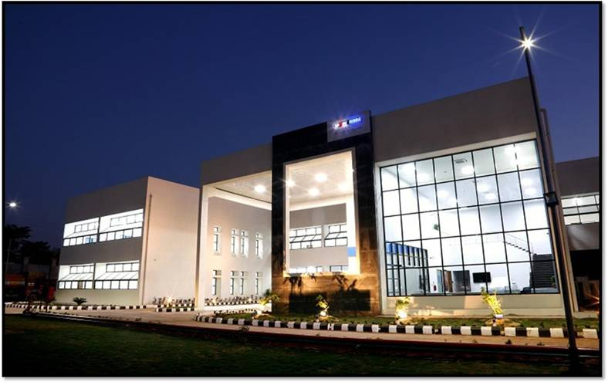

Spark Minda, Ashok Minda Group R&D Centre at Pune, SMIT- Spark Minda Technical Center have built a state of EMI-EMC testing laboratory covering the entire spectrum of EMI-EMC tests such as radiated emissions, radiated immunity, conducted emissions and conducted immunity apart from ESD testing and automotive transient pulse testing. The laboratory is located in the premises of Spark Minda Technical Center (SMIT) which houses a state of art development facility for automotive embedded systems.

According to the company, a unique feature of this facility is availability of the competent design team/embedded laboratory to provide end to end solution to the customers helping them to pass their tests through quick design iterations.

[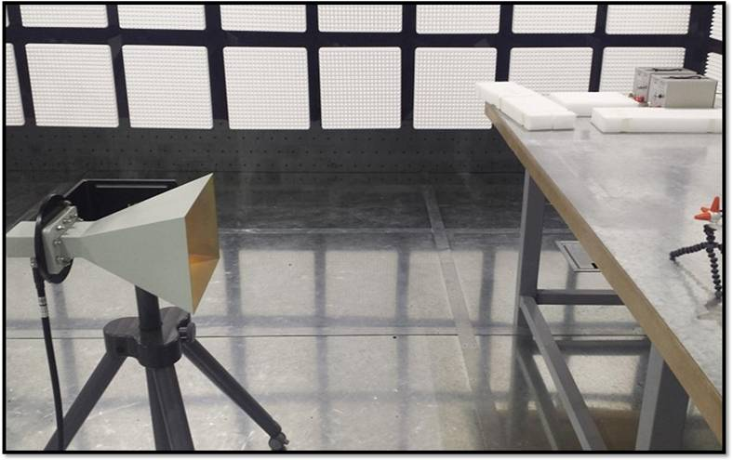](https://autotechreview.com/images/Spark-Minda_SMIT_2.jpg)

SMIT team also offers RF/EMI-EMC simulation services for making early design corrections when the controller design is available only in soft domain viz. PCB Gerber files, Bill of Material and schematics. The laboratory is actively pursuing steps required to obtain NABL accreditation shortly. This will be a unique combination of offering for the automotive customers as the complete EMC solution will be available under one roof - SMIT.

Many customers including leading tier-1 automotive suppliers, OEMs have already started availing of these services and expressed their delight towards proactive role played by the testing team to work shoulder to shoulder with the customers and actively ensure successful passing of the tests.

Electrical-electronic content in a vehicle is increasing exponentially every passing year. Naturally this is impacting associated development and validation life-cycles, which need to address special verification/validation needs of electronic control units and other E&E aggregates. EMI-EMC (electromagnetic interference & electromagnetic compatibility) chamber testing is one area where the automotive engineering community faces toughest challenges towards passing the tests with minimal and early design iterations.

Link - <https://autotechreview.com/news/spark-minda-to-inaugurate-technical-centre-smit-in-pune>

|  |
| --- |
| **Publication: Auto Car Professional** |
| **Edition: Online** |



# Spark Minda develops tech centre with EMI-EMC anechoic chamber testing and simulation services in Pune

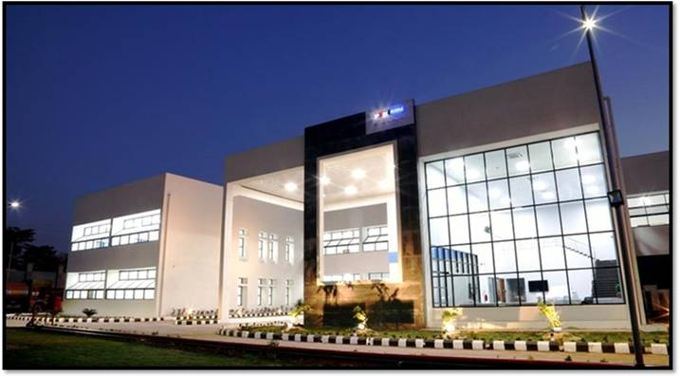

Spark Minda Technical Center in Pune

**With the level of electrical and electronics content in vehicles across segments increasing exponentially every passing year, there is an impact on associated development and validation lifecycles which need to address special verification/validation needs of EVUs and other E&E aggregates.**

EMI-EMC (Electromagnetic interference & Electromagnetic compatibility) chamber testing is one area where the automotive engineering community faces challenges towards passing the tests with minimal and early design iterations. At present, there are very few facilities available in India which addresses the need for validating automotive industry-specific norms.

It is to address such challenges as well as a business opportunity that Spark Minda, Ashok Minda Group has enhanced its R&D Centre in Pune with SMIT (Spark Minda Technical Center, as a division of Minda Corporation.

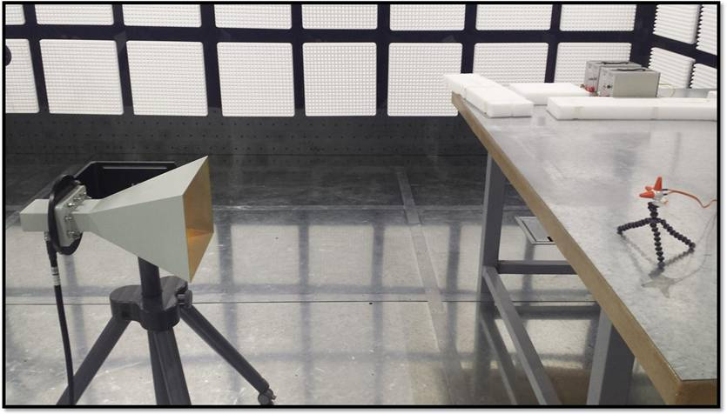

Anechoic chamber with antenna.

The facility now has a state-of-the-art EMI-EMC testing laboratory that covers the entire spectrum of EMI-EMC tests – radiated emissions, radiated immunity, conducted emissions and conducted immunity apart from ESD testing and automotive transient pulse testing.  The laboratory is located in the premises of Spark Minda Technical Center (SMIT) which houses a hi-tech development facility for automotive embedded systems.

A unique feature of this facility, according to the company, is availability of the competent design team/embedded laboratory to provide end-to-end solutions to customers, enabling them to pass their tests through quick design iterations.

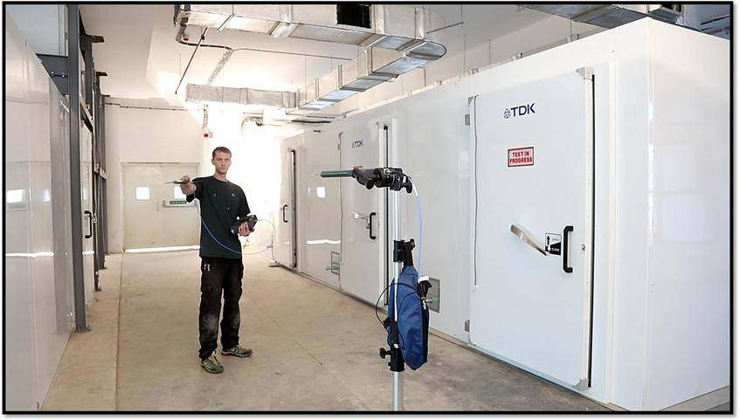

### 

### The EMI-EMC test laboratory.

The SMIT team also offers RF/EMI-EMC simulation services for making early design corrections when the controller design is available only in soft domain – PCB Gerber files, bill of material and schematics.

Many customers including leading Tier 1 automotive suppliers and OEMs have already started availing of these services. The laboratory is actively pursuing steps required to obtain NABL accreditation shortly.

According to Suresh D, Group CTO, Spark Minda, Ashok Minda Group and CEO - Spark Minda Technical Center, “Our EMI-EMC facilities address long-felt needs and pain-points of the Indian automotive engineering community.  We are looking forward to act as a testing partner to most of the automotive subsystem suppliers and ensure them an early success in meeting required EMI-EMC testing norms for their designs.”

 Link - <http://www.autocarpro.in/news-national/spark-minda-develops-tech-centre-emi-emc-anechoic-chamber-testing-simulation-services-pune-2778>

|  |
| --- |
| **Publication: Manufacturing Today** |
| **Edition: Online** |



**Spark Minda to inaugurate technical centre**

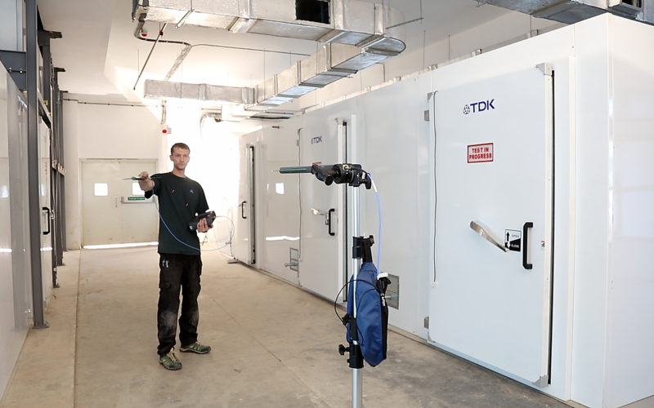

Electrical-electronic content in a vehicle is increasing exponentially every passing year. Naturally this is impacting associated development and validation life-cycles which need to address special verification/validation needs of electronic control units and other E&E aggregates. EMI-EMC (Electromagnetic interference & Electromagnetic compatibility) chamber testing is one area where the automotive engineering community faces toughest challenges towards passing the tests with minimal and early design iterations.

To add to such challenges, very few facilities are available in India which addresses the need for automotive specific norms. Precisely to address such challenges, Spark Minda, Ashok Minda Group R&D Centre at Pune, SMIT- Spark Minda Technical Centre (a division of Minda Corporation Ltd, have built a state of EMI-EMC testing laboratory covering the entire spectrum of EMI-EMC tests viz. Radiated emissions, Radiated immunity, Conducted emissions and conducted immunity apart from ESD testing and automotive transient pulse testing. The laboratory is located in the premises of Spark Minda Technical Centre (SMIT) which houses a state of art development facility for automotive embedded systems.  
One unique feature of this facility is availability of the competent design team/embedded laboratory to provide end to end solution to the customers helping them to pass their tests through quick design iterations.  
SMIT team also offers RF/EMI-EMC simulation services for making early design corrections when the controller design is available only in soft domain viz. PCB Gerber files, Bill of Material and schematics.  
Many customers including leading tier-1 automotive suppliers, OEMs have already started availing of these services and expressed their delight towards proactive role played by the testing team to work shoulder to shoulder with the customers and actively ensure successful passing of the tests.

The laboratory is actively pursuing steps required to obtain NABL accreditation shortly. This will be a unique combination of offering for the automotive customers as the complete EMC solution will be available under one roof – SMIT.  
According to Suresh D, Group CTO- Spark Minda, and Ashok Minda, Group CEO, Spark Minda Technical Centre, “Our EMI-EMC facilities are addressing the long felt needs and pain-points of the Indian automotive engineering community. We are looking forward to act as a testing partner to most of the automotive subsystem suppliers and ensure them an early success in meeting required EMI-EMC testing norms for their designs.”

Link - <http://www.manufacturingtodayindia.com/spark-minda-to-inaugurate-technical-centre/>

|  |
| --- |
| **Publication: Automotive** |
| **Edition: Online** |



**SMIT TESTING LABORATORY CONTAINS SPECTRUM OF EMI-EMC TESTING**

# 



Spark Minda, Ashok Minda Group R&D Centre at Pune, and Spark Minda Technical Centre (SMIT) have built a state of EMI-EMC testing laboratory covering the entire spectrum of EMI-EMC tests viz radiated emissions, radiated immunity, conducted emissions and conducted immunity apart from ESD testing and automotive transient pulse testing.

As electrical-electronic content in a vehicle is increasing exponentially every passing year, associated development and validation life-cycles get impacted.These are needed to address special verification/validation needs of electronic control units and other E&E aggregates. Electromagnetic interference and electromagnetic compatibility(EMI-EMC) chamber testing is one area where the automotive engineering community faces toughest challenges towards passing the tests with minimal and early design iterations.To add to such challenges, very few facilities are available in India which addresses the need for automotive specific norms.

The laboratory is located in the premises of Spark Minda Technical Centre (SMIT) which houses a state of art development facility for automotive embedded systems.One unique feature of this facility is availability of the competent design team/embedded laboratory to provide end to end solution to the customers helping them to pass their tests through quick design iterations.

SMIT team also offers RF/EMI-EMC simulation services for making early design corrections when the controller design is available only in soft domain vizs PCB Gerber files, bill of material and schematics.

The laboratory is actively pursuing steps required to obtain NABL accreditation shortly. This will be a unique combination of offering for the automotive customers as the complete EMC solution will be available under one roof - SMIT.

According toSuresh D, Group CTO, Spark Minda, Ashok Minda Group and CEO of SMITr said,“Our EMI-EMC facilities are addressing the long felt needs and pain-points of the Indian automotive engineering community. We are looking forward to act as a testing partner to most of the automotive subsystem suppliers and ensure them an early success in meeting required EMI-EMC testing norms for their designs.”

Link - <http://automotiveproductsfinder.com/News/SMIT-testing-laboratory-contains-spectrum-of-EMI-EMC-testing/101964>